Supporting the Workforce Case Study / Information
Transforming Psychological Trauma Knowledge and Skills Framework

To date we have integrated the National Trauma Training Programme training resources into the Readiness for Learning ‘R4L’ trauma-informed training e-modules on Clacks Academy for education staff and others. This module integrates Clackmannanshire Council’s trauma-informed approach to closing the poverty-related attainment gap with the NHS Education for Scotland (NES) Knowledge and Skills Framework to highlight the commonalities and integration between the two. Currently around 50 R4L modules are available to Clackmannanshire Council staff. The online delivery of these modules has proved both popular and effective, with over 800 hours of Career Long Professional Learning being accessed in this way between April and December 2021.

Going forward, the Clackmannanshire CPP Trauma Informed working group is proposing to use recent Scottish Government funding to develop a partnership approach across a number of organisations and services which integrates the skills, knowledge and insights from lived experience, professional practice and academic research to support the delivery and embedding of trauma-informed training and practice across Clackmannanshire. This partnership approach would align with other key national and local priorities and developments including NHS Education for Scotland (NES) National Trauma Training Programme, The Promise, Clackmannanshire Council’s Be the Future programme, including STRIVE, and the Driving Change in Mental Health and Wellbeing for Children, Young People and Families Transformation Project and organisational change processes such as The Scottish Approach to Service Design in order to promote wider cultural shifts across organisations and communities. The additional funding would be an opportunity to create mechanisms for effective participation and engagement from people with lived experience of trauma to ‘quality assure’ the implementation of TIP within the Council and its services.

More generally, we have also developed a continuum of mental health and wellbeing supports as part of a wider, whole-systems approach to supporting the mental health and wellbeing needs of children, young people and their families. This continuum of support provides a range of different types of support and choice in how and when to access support (e.g. face-to-face, digital, out of hours, self-management, crisis) for all children, young people and families within Clackmannanshire. An overview of the new and additional services developed as part of the Mental Health and Wellbeing in Clacks transformation project is shown below and information about all the other existing services is contained in the Directory of Supports Website.
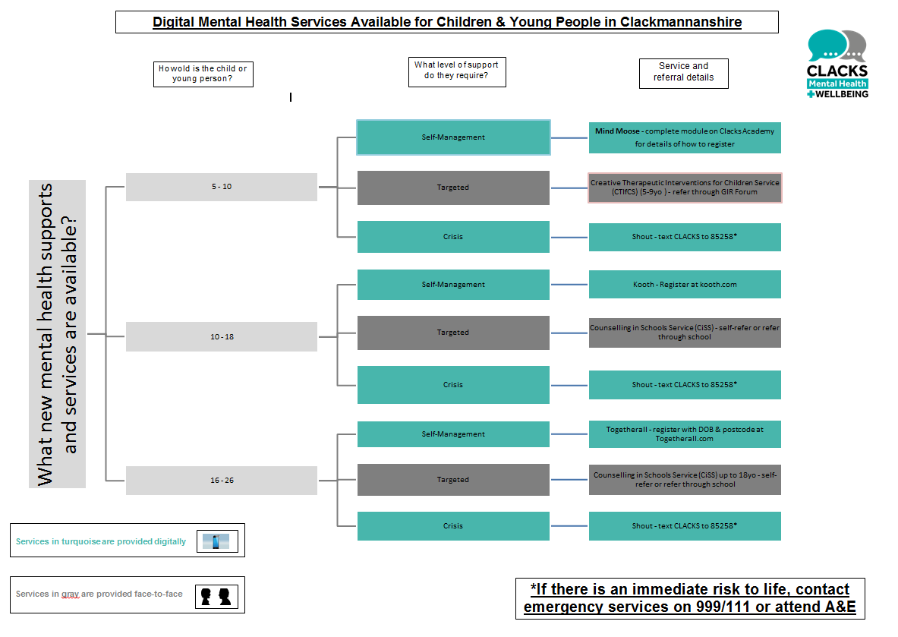

Finally, a workforce development workstream is seeking to embed the NES Knowledge and Skills for Children and Young People’s Mental Health and Wellbeing by using the descriptors under each dimension to form the basis of a self-evaluation tool for staff across all sectors to identify where their current level of knowledge/skills sits so they can identify any gaps. This will then feed into a mapping exercise on what mental health training is available in Clackmannanshire (including both national and local training offers) so that staff across the workforce can develop their own training plans. We will also develop an organisational evaluation toolkit so that managers can identify what level their staff should be at, and to support them to develop bespoke training plans to ensure they get there.

