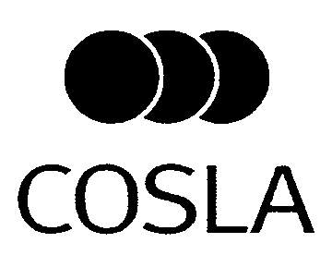
R&SD Executive Group Item 4.2c

Future EU Cohesion Funding for Scotland

Purpose
- To update members of the state of play of EU Structural Funds negotiations and to inform of COSLA recent policy development and lobbying intiatives, including a paper on local development for endorsement.

Recommendation

- Members are asked to:
- Note the developments on the future of EU Cohesion policy;
- Welcome the work carried out by COSLA, Councils and Consortia to influence these discussions; and
- Endorse the evidence paper on Local Development Frameworks included in Annex I

Overview:

- The €308bn EU Cohesion Policy is now under review to prepare for the future EU Budget post 2013. Even with the expenditure, the current allocations for Scotland 2007-2013 of approximately £117m for Highlands and Islands and £434m for the rest of Scotland are only halfway spent, and indeed a number of new options such as the Scottish Investment Bank or the enlargement of Community Planning Partnerhsips are still being proposed, COSLA has been actively working with Councils to define ways of ensuring that Scottish Local Authorities continue to benefit from EU funds and actively arguing the Scottish Local Government case with the Scottish Government, the UK Parliament and the European Institutions.

- Timing is indeed crucial as important strategic policy decisions will take place between now and the end of the year. The future funding for Scotland is by no means guaranteed. In order to advance our EU lobbying work further an additional evidence paper calling for EU Cohesion funding to be targeted to Local Development Partnerships (drafted with the active support from Councils) is provided for endorsement.

Detail

- When EU leaders agreed the current £100bn a year EU Budget between 2007-2013 back in 2005 they included a review clause (at the demand of some Member States including the UK) that would aim to review the spending priorities for the EU. At the moment the Common Agriculture Policy (CAP) and the EU Cohesion Policy (also known as Regional Policy or Structural Funds) amount to more than 60% of EU expenditure, leaving little else for specific funds for Transport, Research, Environment/Climate Change, Entrepreneurship, etc.

- Therefore as the EU Budget post 2013 will certainly not increase, Agriculture and Regional spend are seen as prime targets for cuts as to transfer these resources to “thematic” Funds, and indeed leaks from the Commission showed that this was a proposal. The November Executive Group has already adopted a number of key political messages expressing concern for this shift as this would mean that Local Authorities would be deprived direct access to most of the EU funds.

- On the 9th March the European Commission adopted their EU2020 Strategy which is aimed at bringing forward the competitiveness of the EU economy over ten years and to include in it sustainable development aspects. While this is still pending final endorsement by EU leaders (COSLA has contributed to the public consultation) the EU2020 Strategy will be used by the Commission as their political template for all policy areas. EU Cohesion Policy has a supporting role rathen than being an EU Objective in itself (as it should be under the new Lisbon Treaty).

- The next step will be the presentation of the EU Budget Review in September (COSLA already participated in the earlier stages), which will be discussed during the winter. In parallel each of the big spending EU Policies are reviewing their own priorities, notably the Common Agriculture Policy (final proposal by November), the EU Transport Policy, Reseach and EU Cohesion Policy. COSLA has been participating and influencing the previous stages of these discussion.

- As regards to EU Cohesion Policy, the Commission is now busy preparing the “5th Cohesion Report”, which will be tabled at the end of October and will define the overall architecture and objectives of the future EU Cohesion Policy. In other words, it will define what will or will not be on the table for negotations. The discussions will then progress rapidly as the Budget Review discussions with overall numbers will be known by Spring 2011. The draft EU Structural Funds Regulations will be tabled before the Summer of 2011.

COSLA Lobby work:

- As things stand only Highlands could – with luck- continue to receive some Transition funding after 2013. The rest of Scotland is penalised by the current EU rules as these fail to show the big differences within Scotland in terms of deprivation or basic socio-economic indicators. While a reduction of the funds will be inevitable and that there is limited room to change the basic EU rules (notably eligibility indicators or the scale where they are applied) COSLA has been trying to push domescically and at EU level the line that, should EU funding be available post 2013 they should be directly targeted to those local areas where it can really provided added value.

- Scottish and UK Governments: The Scottish Government is currently assessing the merits of pressing for EU Cohesion funding in Scotland and COSLA was invited to an evidence gathering session by Government Officials in March. Our line has been that, as Cohesion funds are small, they provide added value if spent at a local level using local partnerships, rather as part of a national programme. Proof of this is that a sizeable part of the Scottish Economic Recovery Programme is actually financed with EU Structural funds rather than domestic funds. COSLA is keen to use the Concordat provisions to work with Scottish Ministers to ensure that the Government views reflect Councils priorities as much as possible. In parallel we have submitted (the Executive Group agreed) positions on this issue to UK Government officials as they are already discussion with their counterparts from other countries in the High Level Group on the future of EU Cohesion.

- UK Parliament: The UK House of Lords undertook between November 2009 and March 2010 an inquiry on the future of the European Social Fund in the UK and COSLA was one of the few organisations invited to send submissions and to provide oral and written evidence. Thanks to the very active support from Councils and Consortia COSLA was able to gather and produce abundant evidence of the practical problems that affect ESF and the Structural Funds in general. We are pleased to report that the key COSLA demand for continuity and simplification of EU funds was duly incorporated in the House of Lords resolution as published on 31 March which constitutes the strongest call for continued EU support coming from an UK institution.

- Committee of the Regions: COSLA has been supporting Cllr Graham Garvie who is the Scottish representative at the Territorial Cohesion (COTER) Commission of the EU Committee of the Regions (CoR). He persuaded CoR Rapporteur Mr Schneider to include local partnerships and local development frameworks as one of the proposed delivery strands of EU Cohesion Policy. The Schneider Opinion was approved by the CoR Plenary on 14 April (Cllr McChord and Cllr Knox participated in the vote). Similarly, Cllr McChord is member of the North Sea Intergroup which is preparing a proposal for a future North Sea Strategy, indeed he participated in a Conference April 13 on this issue, including some media coverage in Brussels. COSLA is helping colleagues on the East of Scotland in the preparations an Open Days Conference next October. A possible Atlantic Arc Strategy is also been considered by the European Commission.

- European Parliament: COSLA has regularly briefed Scottish MEPs on the state of play of negotiations. Scottish member of the Regional Development Committee, Ian Hudghton MEP, has tabled a large set of amendments to several reports on the future of EU Cohesion Policy that were voted on 27 April. We are grateful to Mr Hudghton for having taken onboard key views and concerns expressed by COSLA on issues such as the future of Objective 2 funding, need for strong local partnership mechanisms and the preparations for a North Sea Strategy .

- CEMR: COSLA is coordinating the CEMR task force on the future of EU Cohesion, a small but dedicated group of officers from key national associations of Local Authorites, from a cross section of EU Member States, to undertake a collective lobby of the European Commission, arguing for EU Structural Funds to be made more local, and even locally managed. COSLA coordinated a collective submission from several countries arguing for this.

- European Commission’s work on Local Development: COSLA has been trying to influence these discussions since we were aware that the Commission was considering the introduction of a new Local Development dimension in the future of EU Cohesion Policy. This first surfaced when the Commission published a paper in the December “Kiruna Conference” where it outlined the value of Local Development methodologies to be used for EU Structural Fudns to make them more relevant for the local level. The Toledo Summit is expected to take up this discussion at a Ministerial level. COSLA has been busy gathering evidence from Councils and Consortia and meeting Commisison officials, in both public and closed meetings, to discuss the benefits and potential of this idea. We have been particularly active in this as the Scottish Index of Multiple Deprivation and the Community Planning Partneships are excellent selling points that could be used to advance this agenda at EU level as well.

- Members are invited to discuss, amend and endorse the evidence paper in Annex I that has been put together following several rounds of consultation from Councils. We will use this, together with the previous COSLA policy papers, to actively influence the crucial imminent stages of this discussion.

Serafin Pazos-Vidal May 2010
Head of Brussels Office
Convention of Scottish Local Authorities(COSLA)
serafin@cosla.gov.uk

Brussels Office
ANNEX I
Evidence paper - EU Local Development

- The Convention of Scottish Local Authorities believes that the starting point for any decision on the future shape and reach of the EU Cohesion funding needs to be taken on the basis of the multiple challenges that EU citizens and its communities face as starting point, and not on the other way around.

- We agree with the UK Government and other Member States that any future EU27 Cohesion funding should clearly demonstrate European Added Value. In so doing we believe that there are many local areas at sub regional level where domestic funding is not available or insufficient, and where there are either local pockets of multiple-deprivation or structural handicaps that act as a drag on economic performance.

- We believe that local communities are best served by directly targeting EU funds to local areas and that the future generation of EU funds should have a territorial dimension to enable then to reach the ground. We believe that the “place-based approach”, as recommended in the Barca report, should be the guiding principle for targeting EU funds.

- COSLA promotes the idea that a successful application of Territorial Cohesion depends of devolving responsibilities to the level closer to the citizens and ensuring the full application, with clearly identifiable criteria, of the partnership principle. Therefore, we very much welcomed the idea of Local Partnerships as first suggested in the Territorial Cohesion Green Paper. The further evolution of the concept, particularly at the Kiruna Paper and the subsequent REGIO initiatives are very much welcome.

- COSLA believes that there is a wide scope left to improve local input, partnership and delivery in the structure and management of EU Funds.

- We agree with the suggestions that EU funding needs to be made more performance driven. Furthermore we believe that failure to fully implement the partnership principle at the local level could actually prevent the funds from being fully effective. We would welcome suggestions for Single Strategic Framework allowing EU, National and Local authorities and resources to be pooled to address common problems of a given area. This should also help making EU support more flexible and adaptable over the financial period. We believe that the Scottish Single Outcome Agreements are a possible example of the way forward.

COSLA sees with concern the emerging suggestions that EU funds outside cohesion to be increased in size and number of funding streams. We believe that this goes against the previous trend to ensure consolidation (and even reduction) of the EU funding streams and even the stated ambitions of the new Commission for a more focused approach with fewer goals and more critical mass.

- We are also very much concerned about any drive to move European Social Fund or Rural Development policies and programmes away from EU Cohesion policy. Contrary to that scenario, we see the merits of Local Parnerships becoming one-stop-shops of national, EU and private funding being targeted to a given area.

- We support the introduction of additional indicators with a particular emphasis in below the NUTS II level both in order to better identify the territorial challenges but also, if consensus is reached, to better target EU funds to the local level. The Scottish Index of Multiple Deprivation (see below) and the Rurality index are examples of good practice that exist in the Scottish Lowlands and Uplands area that could be used elsewhere.

- While the focus on functional areas is welcome, COSLA would like to stress the importance of ensuring that any these new delivery mechanisms to deliver Local Development Initiatives should should respect (and be subordinate to) the role and competences existing public bodies and the strategic Cohesion priorities within a given region. New cooperation structures, such as the Shared Services model and specific examples among Scottish Councils, are worth exploring in of ensuring critical mass and consistency. On this regard when establishing new Local Partnerships to deliver EU funds, the Commission should ensure that EU Competition issues would be cleared beforehand through specific legislation.

Partnership structures
- Local actors, and most prominently the Local Authorities, should be directly involved and whenever possible, directly responsible (or where applicable, co-responsible) for the design, management and implementation of the funds. However, too many actors would make the decision-making difficult so the governance of such structures should give priority to those actors that have the most direct political and legal responsibilities.

- Partnerships need to have substance as well as form. They are about results and not just about process. Certainly they should not be used to simply legitimise decisions taken elsewhere. By this we mean that the decision making structures should actually enable local stakeholders to make a difference in the final outcome.

- We advocate a more detailed definition of the partnership principle that could be introduced in the new Regulations. Since the beginning of this programming period, several European Parliament reports and research studies have discussed additional criteria such as indicated in this non-exhaustive summary. While some of the below suggestions might be more or less (or even not) relevant for our specific case, the below summary list aims to exemplify that there are still avenues to make parthership principle more detailed than it is defined at the moment.
  - Those partners whose participation is laid down in the Structural Fund Regulations need to be involved in the implementation of all Structural Fund programmes.
  - All public partners to have the same status and voting rights in the monitoring committee.
  - All partners to receive all relevant documents in good time before the meeting of the monitoring committee and to be issued with the full minutes of the meetings of the monitoring committee.
  - MA to establish with the partners a robust and transparent mechanism for responding to remarks and suggestions by the partners. The relevant Managing Authorities to consult on a continuing basis with local stakeholders when preparing detailed guidance notes (and their interpretations) around each call for applications
  - All partners to be involved in determining the criteria according to which projects are selected within the framework of operational programme measures.
  - All partners to receive, as a general rule, the implementation guidance agreed Commission-Member States coordination committees (such as COCOF notes).
Scottish model of subregional indicators:
  - The Scottish Index of Multiple Deprivation (SIMD) 2009 identifies small area concentrations of multiple deprivation across all of Scotland in a fair way.The SIMD provides a relative measure of deprivation which means that the main output from SIMD - the SIMD ranks - can be used to compare data zones by providing a relative ranking from most deprived (rank 1) to least deprived (rank 6,505). The SIMD cannot be used to determine 'how much' more deprived one data zone is than another e.g. it is not possible to say that data zone X, ranked 50, is twice as deprived as data zone Y, ranked 100.
  - The SIMD can be used to identify Scotland's most deprived small areas on the overall index and each individual domain, commonly by applying a cut off such as 10%, 15% or 20%. The cut off should be informed by whether it aims to target areas with the very highest concentrations of deprivation or to be wider ranging.
  - This provides a very detailed picture at subregional and even infra-local level such as shown overleaf.
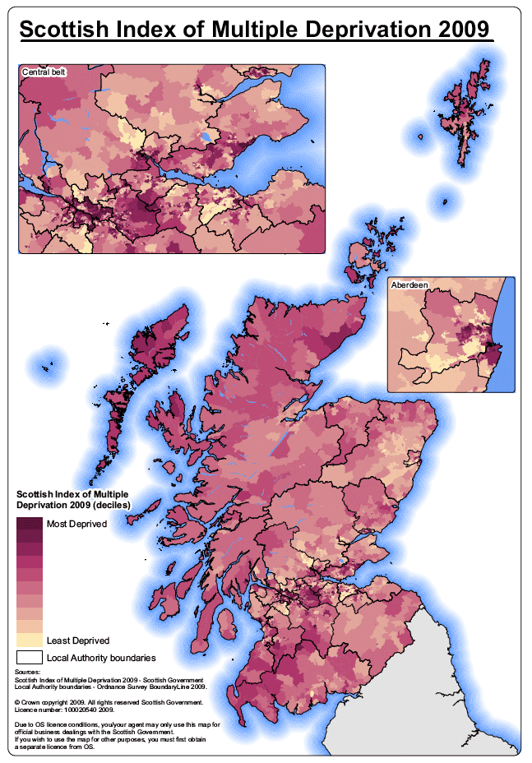
  - The Scottish Index of Multiple Deprivation 2009 combines 38 indicators across 7 domains, namely: income, employment, health, education, skills and training, housing, geographic access and crime.
  - The overall index is a weighted sum of the seven domain scores. The weighting for each domain is based on the relative importance of the domain in measuring multiple deprivation, the robustness of the data and the time lag between data collection and the production of the SIMD. The domain weightings were subject to sensitivity analysis to assess the effects of any changes in weights on the overall index ranks.
  - Prior to weighting, the domains are standardised by ranking the scores. The ranks then undergo a statistical transformation to avoid high ranks in one domain 'cancelling out' low ranks in another. The domain weightings used in SIMD 2009, expressed as a % of the overall weight are: current income (28%), employment (28%), health (14%), education (14%), geographic access (9%), crime (5%) and housing (2%).
Scottish Urban Rural classification:
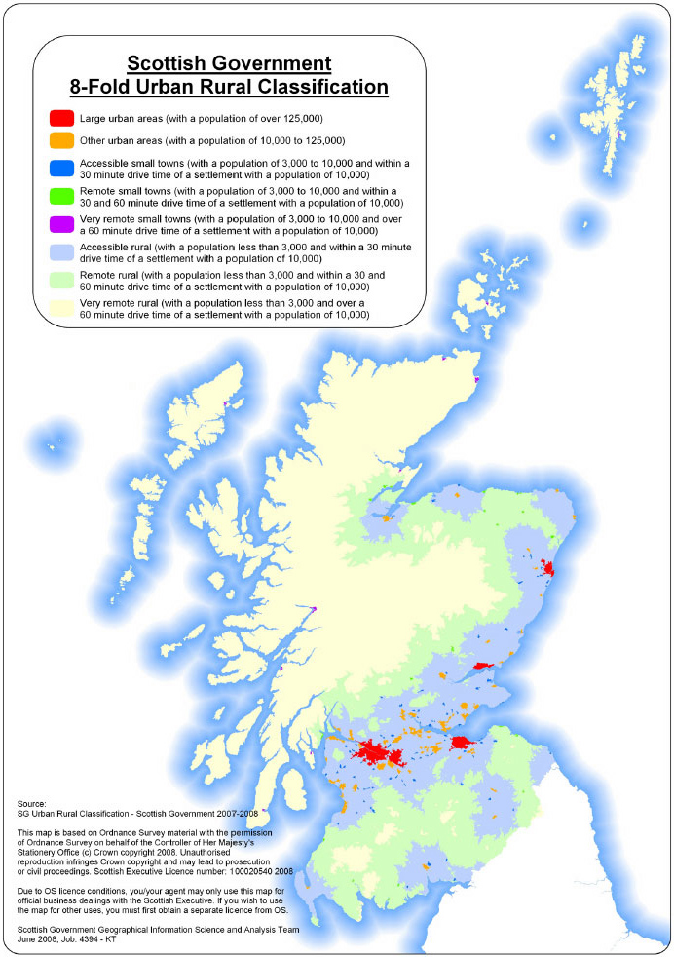
Scottish Government Urban Rural Classification
1 Large Urban Areas | Settlements of over 125,000 people.
2 Other Urban Areas | Settlements of 10,000 to 125,000 people.
3 Accessible Small Towns | Settlements of between 3,000 and 10,000 people and within 30 minutes drive of a settlement of 10,000 or more.
4 Remote Small Towns* | Settlements of between 3,000 and 10,000 people and with a drive time of between 30 and 60 minutes to a settlement of 10,000 or more.
5 Very Remote Small Towns | Settlements of between 3,000 and 10,000 people and with a drive time of over 60 minutes to a settlement of 10,000 or more.
6 Accessible Rural | Settlements of less than 3,000 people and within 30 minutes drive of a settlement of 10,000 or more.
7 Remote Rural* | Settlements of less than 3,000 people and with a drive time of between 30 and 60 minutes to a settlement of 10,000 or more.
8 Very Remote Rural | Settlements of less than 3,000 people and with a drive time of over 60 minutes to a settlement of 10,000 or more.
The this methodology has tried to identify the key problems affecting rural areas such as transport, education and health can have a particular impact on these communities and seeks to reflect this in mainstream policy development.
This classification aids in developing our understanding of the issues facing urban, rural and remote Scotland.
Population thresholds are used to distinguish between urban and rural areas (i.e. 3,000, 10,000 and 125,000) are used to classify the Settlements dataset into 'large urban areas', 'other urban areas', 'small towns' or 'rural areas'. Drive times are then estimated around Settlements classed as 'large urban areas' and 'other urban areas' (population greater than 10,000) to distinguish between accessible and remote areas. For example, in the 6-fold classification, Remote Small Towns are those that fall outwith the 30 minute or 60 minute drive time from a settlement of 10,000 people or more.
Key message: While the additional indicators that exist at sub-regional level in Scotland might be difficult to directly translate at a EU scale, their existence, and indeed their use to target EU Structural Funds prove the point that such additional indicators do exist and can be successfully appliced. They reflect reality in a much more realistic way than NUTS II or even NUTS III classificiation. The current reform process of EU cohesion policy therefore provides an opportunity to define and collect similar indicators EU wide.

While recognising the practical difficulties it would involve, and in order to ensure like-for-like comparisons are made between territorial units, some effort should be made to try to move the current NUTS classification that is set from a mostly demographic criteria to one that aims to reflect more closely similar levels of governance. For instance, depending on each Member State, the NUTS II level is currently made up of regions, Local Authorities, county/provincial bodies and purely statistical areas. This heterogeneous set of governance and territorial levels weakens the analytical basis of the indicators. While like-for-like NUTS could improve the quality of data collected we should stress that this should not necessarily need to have direct consequences in setting eligibility for the Structural Funds.

Scottish Local Development - case studies

Community Planning Partnerships
- The best example of local development partnerships at local level in Scotland during this programming period are the Community Planning Partnerships (CPPs). The CPPs deliver a range of projects across 13 local authority areas in the Lowland and Upland Scotland ESF Programme area (LUPS) and are doing so as a large strategic partnership made up of Councils, Further Education Colleges, Health Boards, the Third Sector and other core partners.
- In the current programmes with more limited resources than in previous EU programming periods there was a need to maintain a local responsiveness characteristic but also to use the more limited funds in a more strategic way.
- Historically the additionality of Structural Funds interventions has tended to vary inversely with the size and geographic scale of the project. At one end of the spectrum the additionality of national standardised programmes is almost impossible to verify. On the other hand the additionality of CP support to localised partners is usually fairly easy to demonstrate. In general the principle of additionality is more likely to be respected if the project is developed and financed on a “bottom up” basis. On the other hand the co-finance model risks EU resources merely substituting for national/regional funding streams with neither scalar increase in activity nor policy innovation.
- Cohesion policy support been the the “glue” that has cemented partnerships that have come together to pursue EU funding for activities that meet their common priorities. It has also facilitated innovative approaches, particularly in ESF (£38 awarded to 13 CPPs until 2010, and 2.3 in Highlands and Islands, with additional £13.7m been awarded last January). At 31st March 2009 (one year into the model) the CPP projects had supported 26,865 participants – the target for the whole priority over the entire 2007-2013 period being 26,000. Nearly 3,500 of these participants had entered employment against an overall programme target of 8.800. Given the rapidly worsening labour market situation in 2008/09 this is a very creditable performance.
- We believe that the CPP model is a case of best practice. An independent evaluation of the CPP approach as a means of channelling Structural Funds was commissioned by the Scottish Government from the consultancy Blake Stevenson in 2009. It’s initial conclusions were that:
- “Overall the CPP model is working well, with some very encouraging and positive signs of the potential of this model of European funding to be a very real contributor to helping CPPs achieve the terms of their Single Outcome Agreement.
- More importantly, where the model is working at its best, it is making a very real difference to the lives of unemployed people in some of the most disadvantaged areas of Scotland.
- Generally speaking there is support for the partnership approach from those most closely involved in the process – the thirteen CPPs.”
Single Outcome Agrements
- The Scottish Government and COSLA have jointly developed what it called a Single Outcome Agreement (SOA) that each Council and the Scottish Government have jointly signed. It encourages each council and their community planning partners to address 15 key national outcomes, and decide on which local indicators are used to measure their achievement at a local level. Each SOA covers a rolling three year period.
- The approach gives a genuine element of local flexibility as each Council and ther partners is ultimately free to prioritise the national outcomes according to local needs, circumstances and priorities. This can mean that a council chooses not to report around national outcomes they do not believe to be a particular priority in their area, and to invest much more heavily in those that are.
- Mutual Accountability: each party to the Agreement (local authority, Scottish Government, and Community Planning Partners) has a shared interest in the delivery of the agreed outcomes, and they will jointly take ownership and responsibility for their respective contributions to these outcomes.
- Therefore, the parties to the Single Outcome Agreement will be able to measure performance, and crucially, to hold each other to account for the delivery of specific commitments they make to enable the delivery of the agreed outcomes.
- Although this has been designed for domestic policies there is scope of using this Multi Level Governance mechanism also to implement Cohesion and other EU policies. As a matter of fact EU Cohesion funding allocated to Scotland and delivered locally via Councils and CPPs do already contribute to meet these Outcome Agrements

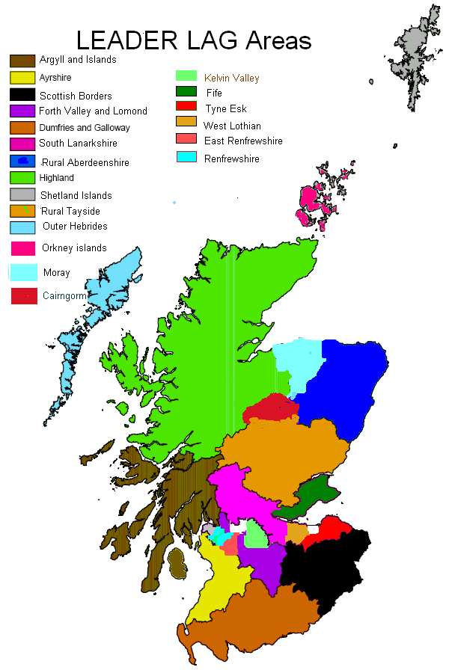
Scottish rural Local Authority Grups
LEADER accounts for 5% of the total Scottish Rural Development (around £38m). An additional £19.2m Convergence Funding has been awarded to 7 LAGs in the Highlands and Islands in recognition of its previous status as a disadvantaged and remote area. Funding is awarded by Local Action Groups ( LAGs) who take decisions on projects which are community driven and have a wide community benefit. Pretty much as the CPPs, these LAGs are a partnership made up of representatives from:
- The Local Authority, Local Enterprise Company, Business representatives, public agencies, Voluntary grups, Community Groups,
As in other countries, there is a feeling that LEADER-like approach could be replicated in Structural Funds, as they:

- Provide true example of bottom-up programming which has improved over programming periods
- Good working partnership from public, private and community levels for representation and decision-making
- Criteria for eligibility has produced coherent and workable areas fit for rural development purposes unlike some other programmes who have tried to combine geographical and thematic targeting.
- The Local Action Groups (LAGs) do fully reflect the Partnership Principle as they based on a consensus approach and are granted a le.vel of local flexibility within the LEADER programmes (e.g. consideration can be taken into account regarding the timings of projects and nature and situation of local applicants).
- This contrasts to the more rigid approaches taken in some of the structural fund programmes.
- Maintains a suitable level of governance despite the bottom-up delivery because the leadership is provided by the Local Authorities – which as a public authority and whose performance is linked to National outcomes.

Specific EU funded- Local Development case studies:

Glasgow Works Contracted Employability Programme:

- Glasgow Works is a City Strategy Pathfinder, one of the fifteen established by the UK Department for Work and Pensions (DWP) which allocated some £6.8m of funding over the two years until March 09. The Glasgow Works strategy also has a role as the employability element of ‘Step Change for Glasgow’ (The City’s Economic Development Strategy).

It has three primary objectives:
- to establish a new contracting mechanism for funding employability services in the city;
- to develop new streamlined services for priority employers;
- to simplify structures and processes for decision making.

with the end aim to effect a reduction in the number of workless residents in Glasgow.

- At the time the strategy was developed (May 06), some 95,000 Glasgow residents of working age were workless, and 88,000 of those were on inactive benefits. Research undertaken at the time indicated that around 30% of these people were interested in working. It was also notable that some specific groups including the over 50’s, young people and members of ethnic minority communities, were extremely disadvantaged.

- The Glasgow Works employability model was designed to ensure a greater focus on engaging with those who are very far removed from the labour market and also on ensuring that support continued after clients moved into work. An additional objective is to increase the number of those taking entry level jobs who receive further training and/or progress upwards with an employer rather than re-enter unemployment.

- In 2007 funding was allocated to Glasgow Works to create the Glasgow Employment Fund, which included a major application for European Social Funds.

- Working towards achievement of one of the primary objectives - ‘establishing a new contracting mechanism for funding employability services in the city’ – a procurement exercise was undertaken and through a competitive dialogue process 5 contracts were let to deliver the Glasgow Works Employability Programme. These contracts were awarded to five Local Regeneration Agencies (LRAs).

- The programme began in July 2008 and will complete in June 2010 and in total is worth around £17m into the local economy.

- The LRAs bid had included a range of named consortium members as well as a commitment to engage with the local supply chain to deliver specialist supports as required by Glasgow Works clients.

- To date almost 20% of the overall contract value has been sublet through Service Level Agreements to around 40 providers and specialist support agencies with the knowledge and experience to support Glasgow Works clients overcome their barriers to employment.

- Glasgow Works originally set targets of 15,000 engagements and 3,000 clients into work. At the end of February 2010, with 4 months of the programme still to be delivered Glasgow Works had engaged with 17,517 clients across our priority target groups and 2,288 had moved into employment.

- This success has been assisted by the work undertaken by GW Job Brokerage initiative which formed part of an ERDF bid directly complementary to the ESF programme. The Job Brokerage staff are based within the Employer Engagement team which includes representation from strategic partners in JobCentre Plus and the Glasgow Employer Coalition. The team work closely together to co-ordinate services to employers, offering a ‘one stop shop’ to assist them to fill vacancies as a result of staff turnover and company growth as well as establishing early relationships with large employers moving new business into the city. The team has delivered a number of successful events in partnership with specific employers aimed at assisting Glasgow Works clients to take advantage of specific vacancies and growth sectors, including the call centre, retail, financial and care sector as well as public services such as Strathclyde Police.

Community Economic development in the East of Scotland
Community Economic Development (CED) was introduced as a new policy priority for the 1994-99 programming period Eastern Scotland Objective 2 and 5b Programmes. Within the East of Scotland Plan Area, large numbers of people continue to be excluded from the mainstream economy. These people tended to be :
  - beyond the reach of the ‘trickle down effect’ because they are not competitive in the labour market which is in turn growing only slowly.
  - concentrated in particular communities where a combination of unemployment, social disadvantage, poor educational achievement, uninspiring environment and exclusion can lead to a vicious cycle of poverty and isolation.
- Under the CED Measures, the type of activities which could be supported included fundamentally those which engage the local community and enable them to actively participate in the design, management and delivery of local development plans. This may also importantly include direct support in researching and preparing local plans, assistance with establishing appropriate local management structures and revenue support for local development workers. Support for social and economic infrastructure eg visitor facilities, training infrastructure, should build upon existing facilities and preferably perform economic and social functions.
- CED-supported activity was set in a strategic context where the locally based strategies are consistent with the local and national policy agenda on social inclusion. This was recognised to l be critical in ensuring the greatest prospect of delivering an integrated and significant programme of activities for communities of need and communities of interest.
CED Example: West Fife Villages
The area known locally as the West Fife Villages included 14 separate settlements, and a widely dispersed population of 13,000. The area is best known for its mining heritage, with many of the villages established and developed to serve the needs of local pits.The double impact of the collapse of the mining industry, and then the loss of manufacturing and defence jobs, had a devastating effect on local employment and on the social and economic welfare of these communities. West Fife Enterprises ltd. was formed in 1983 to provide access to training and employment opportunities for those people who would have otherwise been excluded from the labour market.
Aims and objectives: The fundamental aim is to provide high quality, professional training services to meet the needs of unemployed individuals living locally.
Activities: During the period 1997-1999 this partnership received £750,000 of ESF support and . £170,000 of ERDF support.
The projects supported in providing local people with the skills and competencies such that they may compete for jobs on a fair and equal basis. In particular they provide SVQ level II vocational training opportunities for 45 long-term unemployed people per annum with the aim of helping them secure a job while on the project or within three months of completing the project.
The projects provide multi-skill training within 5 occupational areas:office administration/business computing, carpentry, painting , catering and light engineering.
Results: during this period it was achieved a succcess rate of 75% of trainees moving into full-time employment and 94% of trainees achieving a vocational qualification.

EQUAL Development Partnerships
● The EQUAL Community Initiative produced some interesting and fruitful work during their time in Scotland which finished in 2006. It is an example of a thematic issue being addressed through local partnerships without geographical targeting criteria (other than Scotland wide) which produced strong partnerships and led to long lasting relationships and work that outlived the projects’ time spans.
- The approach to targeting allowed for the best possible partners to work together without needing to abide by other criteria to bring them together, thus having a greater strategic impact than arguably more the locally geographically targeted approaches are able to.

Conclusion:
- The above examples of subregional indicators as well as examples of local development initiatives and partherships that exist in current and past Scottish programmes aim at demonstrating that Local Development Partnerships are a proven and crucial way to ensure that EU Cohesion Policy interventions do provide added value.
- The more localised the intervention and the stronger the partnerships, the more verifiable is additionality, particularly in relatively small Operational programmes such as the Scottish ones.
- Finally, the current NUTS II/GNI criteria limit the effectiveness of the analysis and that of the interventions as they mask the significant sub-regional territorial cohesion challenges.
- While it might be very difficult to change this rationale before 2013, the 5th Cohesion Report should include the possibility of EU supported local development initiatives outwhith the main NUTS II programmes.
- Indeed, in order to ensure real EU additionality, sufficient aid intensity and proper coordination of initiatives, all future local development-related EU funding programmes (within and outwith Cohesion) would be better delivered by Single Strategic Frameworks and where appropiate managed by Local Development Partnerhsips, including EU2020 delivery arrangements.

Serafin Pazos-Vidal March 2010
Head of Brussels Office
Convention of Scottish Local Authorities (COSLA)
serafin@cosla.gov.uk

