Hello, and welcome to the first update about an exciting new development for East Ayrshire’s children and families.

HEART is a new idea to change the way that children and families are supported in East Ayrshire, so that people are able to get help at an early stage and in the communities in which they live. Over the past 18 months, we have listened carefully to many families and practitioners and developed ideas based on what they have told us.

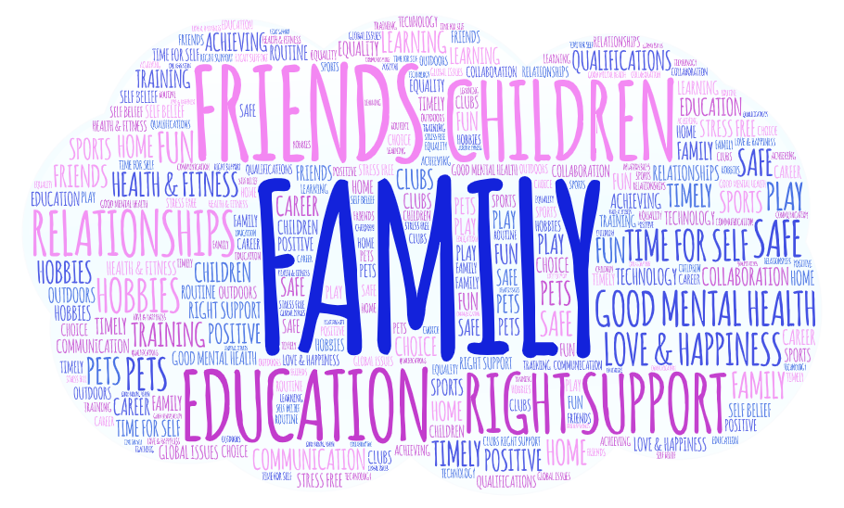
Word cloud representing 847 responses from children, young people, families and practitioners to the question “What is important to you

You might have heard of this before under its old name: the Children’s Services Wellbeing Model. We thought we could do better than this and asked children, young people and parents for suggestions for a new name before putting it to a public vote. More than a thousand of you voted and the clear winner was HEART which stands for Help Everyone At the Right Time. We think this is a perfect summary of what we are trying to achieve and we look forward to telling you more in the coming weeks about the changes we are trying to make.
Our next ask is for some help in designing a logo for the model. We would love to for children and young people to come up with ideas for graphics and images that would fit with the name. The winner will see their design used in all communications about the model going forward and a gift which will be decided on the age of the winner. Entries can be e-mailed to us at WellbeingModel@east-ayrshire.gov.uk.
Please look out for future updates when we will share more about what HEART will mean for East Ayrshire’s families.

