We will listen to you. We will create opportunities and environments for you to talk to us and recognise you as an individual.
Our Promise to You

#AngusPromisePlan

Your Voice

Your Family and Relationships
We will support you to stay with your family, if it is safe, as it is the best place for you to live. Where you can’t stay with your family, we promise to support you to keep and develop relationships with the people who are important to you.
Your Rights and Opportunities to Learn
We will understand and respect you and your care experiences and the impact that these may have on your learning. We will ensure you get what you need to thrive in education by identifying and breaking down any barriers to your learning and being included in school and in the community.
Your Mental and Emotional Health and Wellbeing
We will ensure you have access to a range of different services, so you feel supported to manage your trauma and loss. We will recognise the importance of one key relationship to support you with your wellbeing.
Your Right to Move on to a Bright Future
We will support you, when you are ready, to move on from care. We will behave like good parents by supporting you to be independent whilst also being there for you when you need us.

Keeping our Promise to you!
To keep these promises to you, we need to work together. We will ensure our policies, procedures and importantly our actions are joined up so the Angus ‘scaffolding’ (the people and services) supports your needs.
Where this does not happen well enough or fast enough, we will challenge each other and work together to improve and learn from our mistakes. We will bring everything we do back to what difference does it make for you. We will support the workforce to understand the importance of caring and respecting you making sure we do not make you feel different from your peers by our language or actions.

Our Promise to You - 2022 Update.
A Good Childhood
Advocacy: In Angus, to deliver ‘Our Promise’ we have funded a pilot programme to employ three participation assistants (PAs) through Who Cares Scotland. The project gives these young people valuable experience in Local Authority work and supports their ambitions for the future. Our PAs give children and young people the opportunity to have their say and become part of a family. They are also holding our Promise and Corporate Parenting teams to task to ensure our promise is delivered! We have partnerships with both Who Cares and our local Angus Independent Advocacy to ensure our young people have this support.
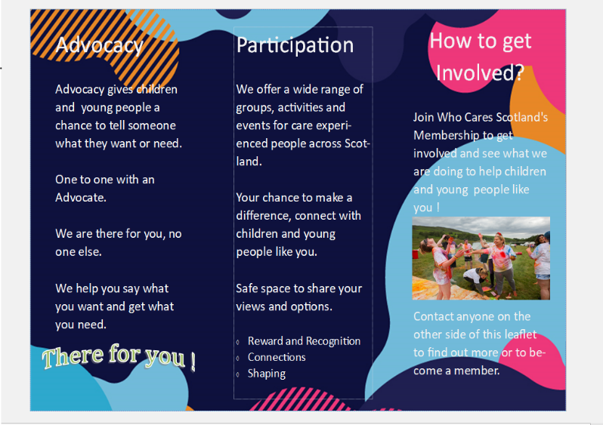
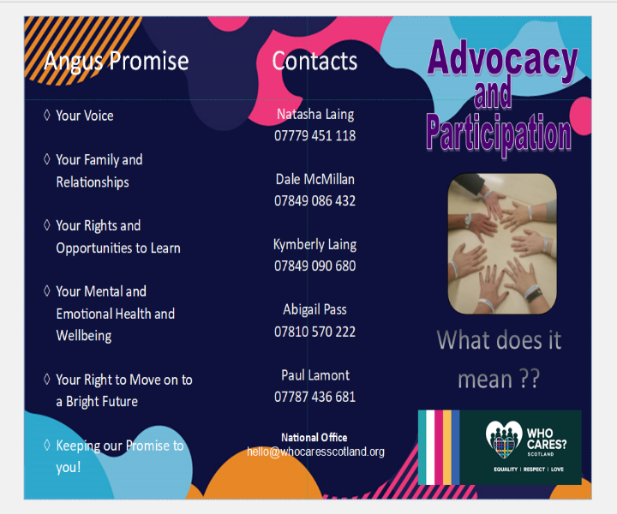
We plan to create “Promise Packs” for all looked after children (current and future) including writing a storybook to help them understand the care system and their rights within that and to give them a place to record their likes, feelings and any questions. We hope to have a group of looked after young people to help design and write this. As a start our fabulous PAs designed this amazing leaflet which has been handed out to local schools.

Whole Family Support
Peer and Community Support: We are working with a local high school developing a pilot social education (SE) module on Care Experience – to educate, inform and inspire secondary age pupils to support The Promise and their Care Experienced peers. The hope is this could be replicated across all year groups, every year, and across all secondary schools in the county, ensuring all children are aware of their rights. We already have interest from several others schools, waiting to see the outcome of our pilot project.
Supporting the Workforce
Trauma-Informed/Relationships/Workforce Support: We are ensuring the voice of our young people are being heard and protected, and using their input to educate our decision-making panels in respect of ‘What it means to keep the Promise?’ (Permanence and Kinship). They are also going to run our Newly Qualified Social Workers group supervision session on the promise. Our PAs are also helping roll out a new assessment strategy across our Children, Families and Justice teams with the aim of ensuring our reports are written with the child at the centre and their voice “unaltered”.
We are also working with our pilot school to hold a twilight session open to all staff to educate them on what their role is in keeping the promise. Likewise we are giving this presentation across our leadership forums in May, to ensure all corporate parents in Angus know their role as corporate parents to our most vulnerable children.
Planning
Information sharing. During Care Experienced Week we kicked off our travelling roadshow with the aim of spreading awareness and making care-experience part of our common language. Reaching over a 100 pupils (who signed our very cool tablecloth) and handed out Who Cares Scotland Merch – including our hot-ticket item wristbands, giving us the inspired idea to create a “Keep the Promise Angus” wristband competition, with the winners designs being made and the bands handed out at our road shows so people can show their support to “Keeping The Promise”. We plan to hold a summer event in a country park open to all looked after children and their friends!
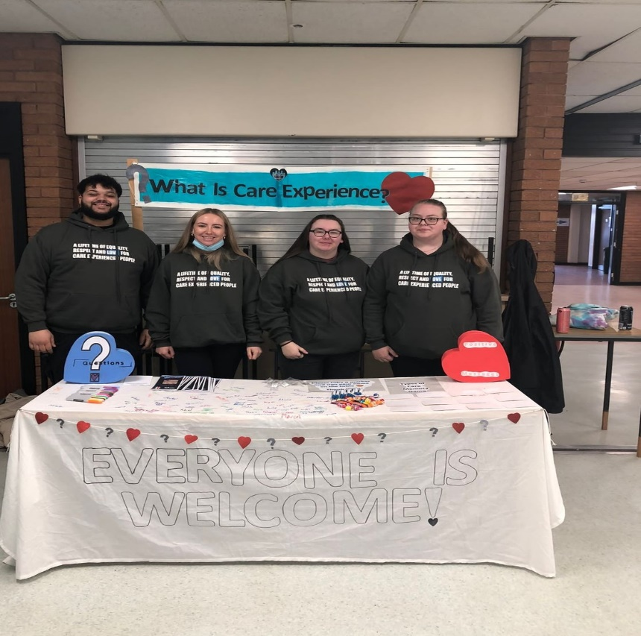

Building Capacity
Legislation: Our commitment to making information easily available and legislation understandable to the people who it affects!
Angus Council is commissioning a new Protecting People website. We want our children, their families, and all our staff to have clear and easy access to vital information in one place! This will include everything from advocacy to explaining our social work processes – from duty, to child protection to becoming looked after. Our aim is to ensure everyone knows their rights, and how to access the help they need and how we can support our children and families when we might not be getting it right – Keeping our Promise to you to learn from our mistakes!
This will include our Promise video, made by our staff and care experienced young adults sharing their lived experiences alongside some of our dedicated frontline workers and corporate parents.

