**Stirling Council’s submission for LG & The Promise Annual Report**

Below are some case studies and other information to evidence progress made in keeping the Promise in Stirling for inclusion in COSLA’s LG & The Promise Annual Report.

A Good Childhood

Stirling Council have also recognised the value of developing our Mentoring Service to support more young people with a trained and committed mentor they can build a relationship with. Stirling has adopted an employer supported volunteering approach to provide staff with paid leave to become mentors. This new service will be launched on 23rd March 2022 and training for new mentors will involve input from Stirling Champs Board, the Promise Lead Officer, Virtual Head Team and Social Work to ensure mentors are trauma informed and trauma responsive. A Mentoring Coordinator will manage the referrals, training and matching process for young people and their mentors and provide ongoing support.

The PDF of the flyer for the staff mentor launch is attached along with this report.

Stirling Council continue to support our Champs Board through the funding of a full time Development worker and 3 part-time participation workers, two of whom have lived experience of care. We have repurposed a part of the Council’s estate to provide a permanent physical base for our Champs and they have successfully fundraised to decorate and furnish it as a homely and welcoming space for young people. Known as the Home & Belonging Hub this space includes a kitchen/dining/living space, cosy gaming room, general purpose areas and bathrooms. The space is well used with sessions for Mini Champs (aged 5-10) on Saturdays, champs (aged 11-15) on Monday evenings and Champs (16+ years) on Thursdays. Young people are involved in cooking and baking and often prepare meals for the whole group, birthdays and special achievements are celebrated and activities and workshops with local artists and corporate parents are facilitated. Out with these weekly sessions the space can be accessed daily during the week for any young person needing advice, support or a safe place to study, socialise and spend time. There are opportunities to meet with social workers, income maximisation officers and complete person centred plans in the space at any time. The Champs are being supported by members of our Corporate Parenting Group to develop their own plan to utilise the Home & Belonging Hub to offer Brothers and Sisters time and activities to nurture their relationships as part of Stirling’s efforts to #KeepThePromise.

Below is an image of a window in the Home & Belonging Hub decorated by the Stirling Champs as part of a recent Window Wonderland community arts event:

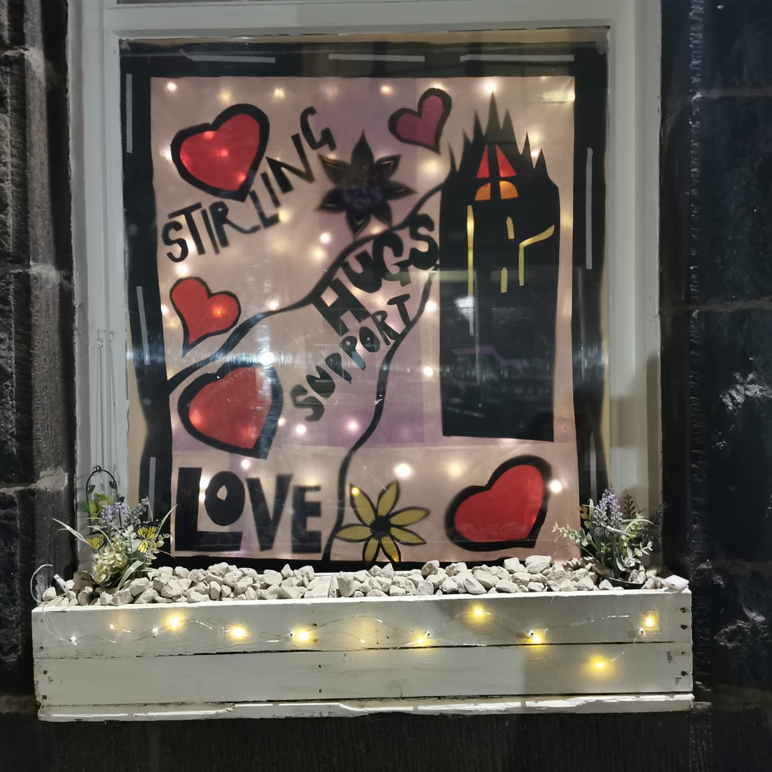

Whole Family Support

We are implementing a broad range of improvements that better support children, young people and families. For those already in the care system we continue to support more children and young people in their extended families and local communities, and reduce the length of time that statutory measures are required, and we are identifying opportunities to put in place earlier support and intervention to prevent children entering the care system. The total number of looked after children has reduced from 225 at the start of 2020/21 to 193 by the end of the year. The reduction of the overall number of children and young people in the statutory system is integral to our implementation of The Promise.

We have reaffirmed our commitment to rebalancing of care in Stirling and since the launch of The Promise in early 2020 we have reduced both the number of young people in residential care and in foster care by approximately a third.

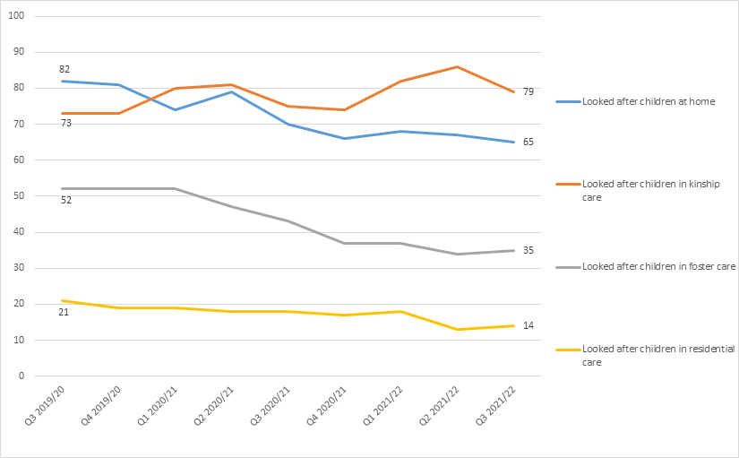

Supporting the Workforce

In February 2022, to coincide with Care Day and the Tending the Light Festival of Care we launched our Corporate Parenting Elearning Module. This interactive module was developed collaboratively with Stirling Champs Board and some of the young people’s voices feature in training. The launch was widely publicised to staff as our elearning module of the month and we shared it with partner agencies, including Police Scotland, Scottish Fire and Rescue Service and Skills Development Scotland. The module is available for all staff and has been made mandatory for team leader level and above. It will be completed by the Schools and Learning workforce during Staff Development days at the beginning of each academic year. In the first two weeks of the launch it was completed by 230 members of staff. Completion reports will be monitored and Champs Board are being kept appraised of the positive feedback the module has received, including that it is “accessible and informative”, “the young people’s voices really hit home” and is helping staff understand and value their role as corporate parents.

Here is a link to Stirling Champs Board’s Letter to corporate Parents which forms part of the training module: [Dear Corporate Parent - Stirling Champions Board - YouTube](https://www.youtube.com/watch?v=ZDVqqAYMN9M)

Below is an image from our corporate Parenting elearning module.

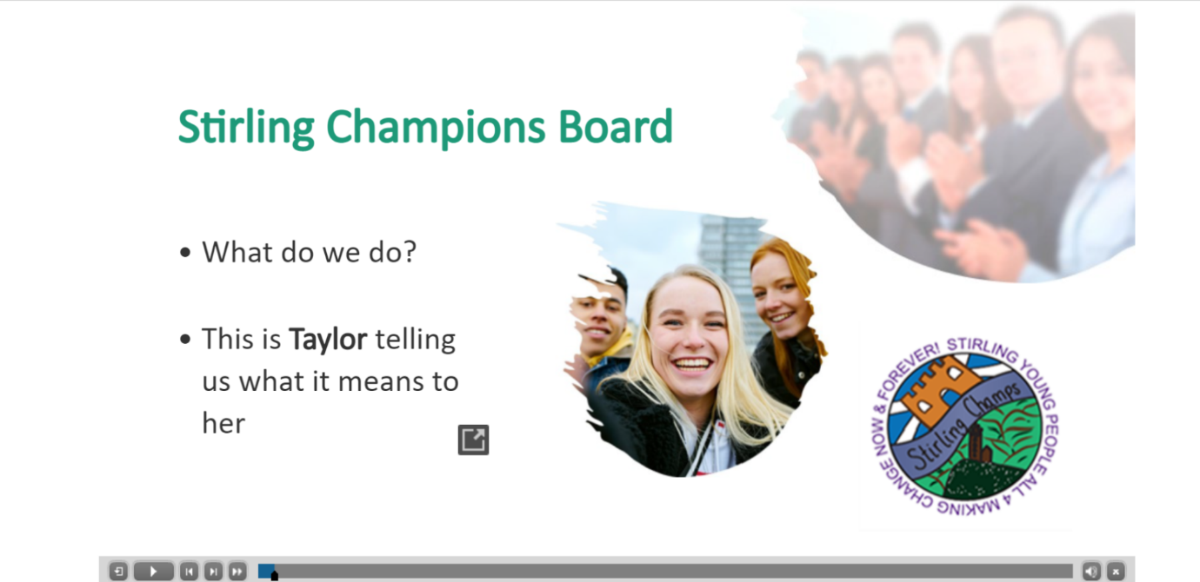

Planning

We have aligned our Corporate Parenting and Promise Plan 21 – 24, corproduced with young people, parents, carers and the workforce, and this was approved by our Children and Young People’s Committee in February 2022.

We held a series of staff conversations and coproduction workshops with young people with experience of care to inform our Plan 21 – 24. We listened to our Champs when they told us that they felt that there was not enough follow up and feedback following their consultations with us and to address this we held a feedback session before the Plan was published demonstrating where their contributions had resulted in specific actions within the plan. The Champs told us this gave them confidence that the culture in the Council was changing and they felt listened to and valued. One young person said it gave them hope that things would change much more quickly than they had expected and they now had belief in the managers to make the changes that are needed.

Below are some presentation slides from the feedback session with our Champs:

