Falkirk’s Progress Plan in fulfilling its Promise to safeguard and promote the wellbeing of our care experienced young people and care leavers - March 2022
Purpose of the Report
The following captures the breadth of work being undertaken across Falkirk Council, and the progress being made across Falkirk to #KeepThePromise in the two years since The Promise was published.
Sara Lacey, Head of Social Work Children’s Services and Chief Social Work Officer, Falkirk Council, pledged support in #Keeping The Promise: -
Sara’s Pledge
To support the work of the review. To deliver lasting change in the care system
I will do this by carefully considering the recommendations for change and breaking down any existing barriers (with partners, the workforce, the community) which will delay or impede progress and required changes

This encapsulates what Falkirk is striving to achieve in the actions being taken to fulfil The Promise.

Details & Format
This report will feature some of what has been achieved by Falkirk within the ‘Five Priority Areas’ as noted with The Plan 21 -24.
The report reflects the requests from our young people to change some of the language that we use when describing their personal circumstances and their experience of the care system.
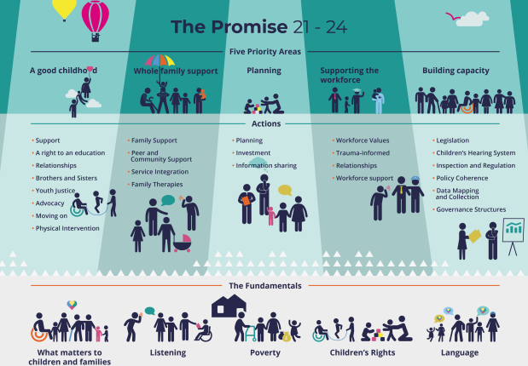
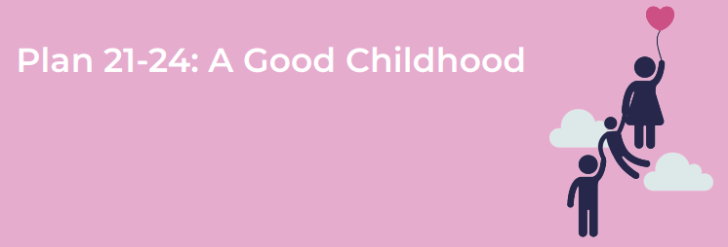

Falkirk promises to:
1. Improve relational connections for young people with significant people in their lives.
1.1 Falkirk have invested in services which foster new and improved methods of communication with young people and their families. As well as aiming to improve relationships between family members, this also aims to reduce the possibilities of children and young people being removed from their own homes; or for others, increases likelihood of young people returning to their family home.
- Aberlour Sustain Service, Falkirk - working with families over 7 days a week, 7am to 10pm, allows support to be offered flexibly and be tailored to meet individual families’ needs. This is designed to help them to sustain their children and young people to remain in the family home.
- Family Group Decision Making – Barnardo’s have been commissioned to facilitate sessions with young people and significant people in their lives. This process empowers families by placing them in charge of developing their own plan which will guide their future.
- Includem Service - working with children and young people to enable them to transition from care back to their families and communities. This service is designed to help to build confidence, self-esteem and improved mental wellbeing for young people they support.
- Life-Long Links – Barnardo’s work with individual young people helps them establish or re-establish connections and relationships with people. This includes supporting the young person to consider the nature of different relationships and may lead to connections with people who can offer emotional and practical support. Some may hold the young person in mind for special occasions such as birthdays and Christmas. This could involve family members, friends, neighbours, social workers, staff from other disciplines etc.
- Reducing the need for restraint - Falkirk is represented on the national residential services network set up to explore alternatives to restraining young people who may be a risk to themselves and to others. The alternatives will be informed by trauma informed and responsive approaches.

Falkirk promises to:
2. Reduce the number of transitions for young people in our care by aligning Falkirk’s 2 specialist homes for young people.
- Falkirk Council’s has two children’s houses for children and young people who cannot live with their families. Falkirk is currently working to align both houses to enable young people to remain in this setting for as long as they wish. In providing stability and reassurance for young people, this will reduce the number of transitions they may otherwise face; this will provide greater opportunities to build and sustain relationships with their peer group and with the staff caring for them

- For young people with additional needs, Falkirk has been actively working towards improving their experience of transition from childhood to adulthood while also improving the support to their families. 2020/21 has seen real progression of plans to achieve smoother pathways. In adopting a ‘lifespan approach’, this has been made possible through several joint activities involving Children and Adult Services: i.e., formation of a multi-agency Transitions Steering Group and the appointment of a new post of Transitions Co-ordinator. Funded by Looked After Children Attainment fund, Falkirk has seconded a Social Worker who has experience and a particular interest making changes for young people in preparing them for transitioning into adulthood. The Social Worker is working alongside ASN school provision and Social Work staff from Children and Adult services.
In 2021 Falkirk was chosen to partner with the Scottish Government and Association for Real Change (ARC) to pilot enhanced transitions based on the ‘Principles of Good Transitions’.

- Brothers and sisters: Work is underway prioritising brothers and sister’s relationships. This includes increasing the number of foster carers who can care for brothers and sisters within one home. For those who cannot live together, Falkirk is working on assessments designed to lead to best planning in how brothers and sisters can continue to have meaningful connections with each other. This work also includes co-designing premises known as ‘The Lodge’ to make this more conducive for families spending time together.

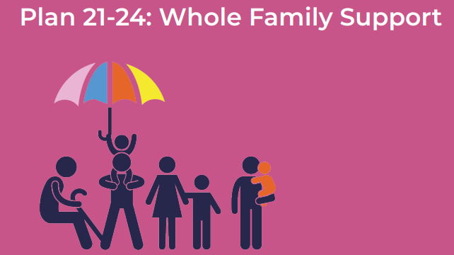

Falkirk promises to:
3. Support families to prevent young people from being in the Care system
4. Work collaboratively with young people and family members to develop skills and strategies for managing challenges and successes

3 & 4 a. As noted within ‘A Good Childhood’ there are several initiatives in place to reduce the likelihood of children and young people having to live out with their family home; to support those living away from their families and to increase the likelihood of children and young people being returned to their family homes.

b. Falkirk has invested in work that supports wider communities locally. This will also be of benefit to our care experienced families e.g. Trauma service: Equally Safe Falkirk project to work with children, adult survivors, and perpetrators of domestic abuse; Inclusion and wellbeing Family Support staff linked with specialist school provision.

5. Align our Family Support and Intensive Family Support Teams
Falkirk’s in house family support services are being aligned and co-designed to create a more holistic approach to supporting children, young people, and their families.

.
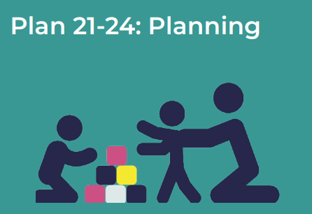

Falkirk promises to:
- Re-imagine Champs Board to include more young people and for the meetings to be relationship based and young person led
- The establishment of the Champions Board was one of three priorities in our first Corporate Parenting Plan (embedded in the Integrated Children’s Services Plan). This is now mainstream and well established. This group will continue to play a pivotal role as Falkirk’s embeds The Promise across the partnership.
Falkirk Champions Board | Life Changes Trust
Falkirk Champs and the Promise - YouTube
- Staff Induction to Falkirk Champs Board – The Board have created a film to explain what they need from Council staff - i.e., to be listened to, to be understood, and for them to learn what being a care experienced child or young person means. This film is also presented to new employees as part of their mandatory induction and is introduced by care experienced young people. An information session on Corporate Parenting is now a key feature of Corporate Induction and this is led and facilitated by Falkirk Champs.
- Training Resource – Falkirk’s online workforce development training resources includes a presentation on Corporate Parenting. This has been designed by young people to inform the workforce of The Promise and of their responsibilities as Corporate Parents (Council’s Family & Friends).
- Policy changes - The Champions Board has impacted on a range of practice and policy areas including Housing Options Protocol for care Leavers; Corporate Learning and Development Policy which includes Corporate Parenting and links to awareness raising and staff training.

Falkirk promises to:
- Work in partnership with other Champs Boards, sharing ideas and resources
- Work has begun in partnership with North Lanarkshire and Stirling Boards.

Falkirk promises to:
- Enhance strategic governance to take account of the different work strands that influences the work of Council Family and The Promise
- Falkirk’s Children’s Commission Group is now known as Falkirk’s Children and Young People’s Leadership Group to more accurately reflect the wider remit addressed by this multi-agency partnership. It is responsible for overseeing the Integrated Children’s Services Plan which includes all children within the Falkirk locality. One of workstreams reporting to this Leadership group is focused on how Falkirk is meeting its Corporate Parenting duties and adhering to The Promise principles.
- Parents and Carers Reference co-design group is planned to shape and influence policy and practice developments. This group aims to empower and enable adults with experience of the care system to support each other and to share learning about what could have been done differently and what helpfully led to positive outcomes.
- Change of ‘care’ language – The Champs Board have considered what language has been used to describe their experience of being in the care system and they have given a clear message of what not to say or write e.g., Corporate Parenting is now described as Council family and friends. The young people readily support change by correcting use of stigmatising language and have developed the attached power point as a resource in support of their points.

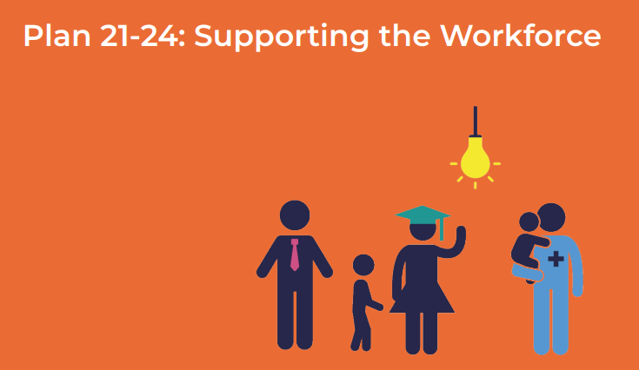
Falkirk promises to:
- Support staff to embed the culture of The Promise in their work
- Training & development - Funded by Corra Foundation, Falkirk has recruited a Keeping The Promise Training Officer. This post is pivotal for the development, co-ordination, and facilitation of multi-agency training, learning and development and will embed the Corporate Parenting responsibilities and The Promise’s priority areas.
- Staff health and well-being - Falkirk are committed to organisational and employee well-being. There is a programme of trauma skilled training being delivered which includes a focus on nurturing the nurtures.
- Flexible working - Given the significant shift in using technology Falkirk have invested in providing the right technology to allow for flexible working alongside prioritising relationship- based practice.

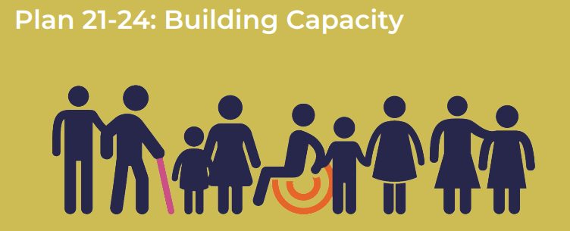
Falkirk promises to:
- Embed learning from the Relationship First Project, action the three service design prototypes and implement the Council Family learning and development strategy.
- Relationships First Project was a participatory design demonstration project funded by The Life Changes Trust. It supported 8 care leavers and 10 members of the workforce from Falkirk Council to collaboratively design services that put love and relationships at the heart of leaving care service provision. Falkirk took the bold step to explore what barriers young people experience in being able to develop and maintain healthy relationships and then look at what could be done differently to put relationships first. Three service design prototypes were developed – two suggested policies and one framework. ‘Hug in a Mug’ Policy Service Design – Hug in a Mug | Relationships First and approach, ‘Share the Care’ Policy Share the Care | Relationships First and approach and ‘Heart on Sleeve’ Framework Process 16: Our final idea: Heart on Sleeve | Relationships First. The films are located on the Relationships.net website which is another workforce development resource created during the Project. About Relationships First (falkirk.gov.uk)

- The learning from this project is being made into a series of short films. These will showcase the systems leadership approach and service design methodology. These films will be shared to generate further workforce participation in co-design and co-production.

Falkirk promises to:
- Collate and share practice examples of how services are embedding the Council Family responsibilities and The Promise priorities in their practice
- Education, Children and Young People Executive - A young person from the Champions Board is elected to represent care experienced children and young people at the Executive Committee. Their role is to contribute to committee meetings and support the preparation of relevant papers and presentations.
- Young People’s participation in recruitment – there is an increase in how Falkirk involves young people in recruitment e.g., young persons’ panel interview for the Keeping The Promise Training Officer post, the Champions Board Coordinator, Participation Assistant role and residential childcare positions.
- Young People’s participation in the Children’s Hearing system – the Champions Board contribute to panel member training and have co-designed learning material.
- Modern Apprenticeship for care experienced person – mentored by Keeping the Promise Training Officer. Falkirk is committed to recruiting several young people into modern apprenticeship positions aimed at young people becoming permanent employees on successful completion of their apprenticeships.
- Family Firm – Life Changes Trust funding supported the development of the Family Firm approach where in house work experience resources have been matched with care experienced young people. This project was adversely impacted by Covid-19 however some progress was achieved through creative use of online technology. This work has strengthened the knowledge and skills of the workforce so that they are more able to meet the needs and aspirations of care experienced young people. Falkirk Family Firm | Life Changes Trust
- Falkirk’s Children & Families Training Manager attended the Promise Design School. The learning from this experience informed the development of Falkirk’s new Equally Safe Falkirk partnership project shifting thinking from service user to service co-designer. Falkirk aim to bring together Council employed Service Designers with partners developing knowledge and skills in service design. This will build a local network alongside our commitment to the Promise Leads network. Recent work on improving Kinship Care processes and procedures is another example of improvement through implementing service design methodology.

Falkirk Contact Details
Name: | Sara Lacey
Job Title: | Head of Children’s Social Work Services and Chief Social Work Officer.
Email: | sara.lacey@falkirk.gov.uk
Telephone: | 07786083680

