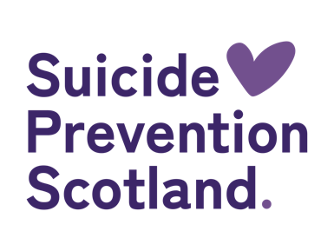
Gathering Hope Event Report

Event Summary

Suicide Prevention Scotland hosted an event to bring together third sector organisations. The day included presentations, conversation cafés, and opportunities to network and connect to with others within the suicide prevention community.

Around 120 people had signed up for the event, but due to poor weather conditions there were approximately 70 attendees representing 50 organisations.

The day began with messages from Maree Todd, Minister for Social Care, Mental Wellbeing and Sport and Councillor Paul Kelly COSLA Spokesperson for Health and Social Care.

Haylis Smith, Scotland’s National Delivery Lead for suicide prevention, introduced a moment of remembrance for people who have died by suicide. She then set out the purpose of the session to:
- Enable connections between those working on suicide prevention across Scotland
- Build insights and expertise on what it will mean to do this well
- Identify opportunities for working together

This was followed by presentations from third sector organisations:
- John Gibson – The Canmore Trust
- Alex McLintock – Andys Man Club
- Chris Paul – Man On! Inverclyde

Each speaker shared their work, achievements, and the challenges around suicide prevention. This was followed by a Q&A session.

All three speakers were incredibly powerful and insightful, and it was great to hear each organisation’s individual insights but also see where there was commonality.

Lunch provided an opportunity for attendees to mix and network in an open an informal space.

The afternoon involved two rounds of conversation cafes with tables covering 9 topics based on the top priorities selected by attendees through a survey issued prior to the session. There was also a table for anyone needing a quiet space.

CONVERSATION CAFÉ TOPICS
Raising awareness and improving learning about suicide | Whole of government / partnership working | Time Space Compassion approach
Supporting new peer support groups | Work with partners in high risk settings for suicide | Suicide risk behaviours amongst children and young people
Step up United to Prevent Suicide | Developing an online portal | Suicide Prevention Scotland and the third sector
Time Out Space

The conversation cafés provided an opportunity for rich discussions. A summary of key points is provided in the next section of this report.

It was initially planned to have three rounds of conversation cafés, but due to deteriorating weather and travel conditions it was decided to end the session early.

Haylis thanked everyone for their time and contributions and set out the next steps, which would include pulling together learning and sharing outputs from the session.

A feedback survey was shared after the event and a summary of responses is included at the end of this report.

Conversation Café Discussion Summary
Two rounds of conversation café’s were held on the day. Attendees self-selected which table/ conversation they wished to join and were free to move between tables throughout the sessions.

Each conversation café session asked the same questions of attendees:
- On this topic, where do you see key opportunities to take action/ do things differently
- From your perspective, what would support that?
- …and what’s likely to get in the way?
- What opportunities for action/ working together is it important to get down on paper?

The following sets out a summary of the discussions which took place at the conversation café sessions.

Raising awareness and improving learning about suicide

On this topic, where do you see key opportunities to take action / do things differently?

- Training –
  - Enable access to training and reduce barriers to attendance
  - Match capacity and provision to meet demand.
- Community –
  - Recognise it takes a community to prevent suicide
  - Build better understanding of what exists in communities and enable opportunities for more connecting and working together
- Access – Building more hubs on people’s doorsteps and create spaces for people to talk

From your perspective, what would support that?

- Training - ensure training is delivered within undergraduate programmes e.g. nursing, medicine, teaching rather than taking people out once they are in a job
- Community –
  - Wider consultation with the community and a forum to raise all the challenges/issues
  - Appropriate resourcing and funding
  - Available spaces in the community
  - Bring the community knowledge and expertise to the table to build partnerships
- Communication –
  - Openly talking about suicide
  - Connect to education services about suicide and the need to address it
  - More communication and planning spaces for organisations

…and what’s likely to get in the way?

- Lack of resources – This includes funding, time, space and expertise, too busy doing work to do additional learning
- Community – competing with other organisations for the same limited resources
- Stigma – suicide is still a taboo subject
What opportunities for action / working together is it important to get down on paper?

- Location – mapping demand and capacity for all levels of training across the country would help identify geographical barriers and inconsistencies
- Working together - National organisations helping local ones to get involved on an equal footing. Sharing good practice as when we get it wrong. Not one of us is as smart of all of us
- Training - Funding access to relevant training in Scotland

Whole of Government/partnership working

On this topic, where do you see key opportunities to take action / do things differently?
- Connections –
  - Getting into a variety of sectors to address the social determinants of suicide directly
  - Working in corporate and private sphere on awareness raising
  - Having meaningful ways of sharing information with similar services
  - A directory to connect people to services that covers both third sector and statutory
- Mapping –
  - Map the existing ask to find out what more people could do and what do they need to do it
  - Community mapping to look for opportunities to collaborate
- Incentives –
  - Support Scottish Government (SG) and Local Authorities (LA) to reframe effective and destigmatising delivery as suicide prevention
  - SG/LA’s provide incentives to recognise their responsibility and accountability to suicide prevention
- Lived experience – the voices of people with lived and living experience should be present throughout service and policy design and delivery as they are our best guide, and they want to tell us what they need

From your perspective, what would support that?
- Connection –
  - Engage with business organisations and large corporate organisations
- Lived experience –
  - Lived and living experience should be at all levels of decision making
  - Practice should be ethical and genuine co-production not an afterthought
- Communication and information –
  - Being clear with what the ask is, third sector know their priorities and they should be heard
  - Identifying services who are suicide aware/focussed in their policies working with other providers
- Resourcing – organisations need consistent funding, education, and access to training

…and what’s likely to get in the way?
- Resourcing –
  - Funding - lots of organisations trying to access same funding hinders collaboration
  - Transient nature of some funding
  - Organisations may not have spare capacity or time to participate
  - Prioritisation of other sectors
  - Organisations feeling resentful at being asked to take on additional responsibility
- Interventions – the lack of psychological interventions/NHS treatment available combined with a need for individuals to have effective support at time of presentation/ need
- Awareness – red tape and not fully understanding what is needed to prevent issues and education before reaching crisis point
What opportunities for action / working together is it important to get down on paper?
- Links – wellbeing economy in SG and needs dedicated independent coordination

Time Space Compassion approach

On this topic, where do you see key opportunities to take action / do things differently?
- Leadership – what is needed for support to enhance delivery Time Space Compassion
- Collaboration – lots of opportunities to work together to raise awareness of Time Space Compassion and encourage others to create safe spaces
- Recognition – recognising what third sector do is Time Space Compassion

From your perspective, what would support that?
- Connection –
  - In person opportunities for peer connections across sectors and organisations
  - Opportunities for collaboration
  - Support for leaders
- Consistency – consistency of approach
- Commitment – real commitment whatever that means in each individual case from third sector and from Scottish Government

…and what’s likely to get in the way?
- Resources –
  - Time constraints/ pressures in organisations
  - Limitations on funding
  - Busyness
- Lip service – not following same ideals or awareness and not connecting with others

What opportunities for action / working together is it important to get down on paper?
- Connection –
  - Important we can engage with each other to build working relationships across the sector and have a collective approach
  - Coming together to shout about the benefits of Time Space Compassion
  - Building peer connections
- Branding – Branding Time Space Compassion and getting it out into safer spaces

Supporting new peer support groups

On this topic, where do you see key opportunities to take action / do things differently?
- Connection –
  - Opportunities for collaborating
  - Bring organisations and the community together
- Recognition –
  - Value of peer support should be recognised/ peer support work paid.
  - Highlight the strength of peer support to ensure as seen as a legitimate alternative to more traditional and clinical support.
- Support –
  - Support peer supporters to take time out of work for peer support, the sector needs support and financial support.
  - Peer support needs to remain lived experience led and not taken over by experts
- Access –
  - Peer support should be available early not just when someone is well/looking to keep well
  - It should be available at prevention and intervention level not just postvention.

From your perspective, what would support that?
- Training –
  - Peer supports need knowledge of and access to training such diversity, listening skills, mental health, neurodiverse populations
  - Training for group facilitators.
- Directory-
  - Directory of groups
  - A map of peer support services and who they are for, where they are and kept up to date.
- Commitment – work/finance commitments

…and what’s likely to get in the way?
- Commitment –
  - Uncertainty of funding for peer support in general
  - Peer supporters should be paid
- Evaluation – lack of evaluation on what is successful
- People –
  - Peers may also be still dealing with their own situation
  - Boundaries and relationships
  - Financial barriers
  - Time.
- Support-
  - Lack of understanding of what peer support is and conflating with support work
  - Lack of services to signpost people to once peer support ended
  - Lack of specific support around suicide and peer support
- Organisation risk

What opportunities for action / working together is it important to get down on paper?
- Value –
  - Sharing experiences helps other people without realising it
  - Recognition that peer supports are valuable
  - Recognition of how much of their own time peer supporters giving
- Good communication is necessary

Work with partners in high-risk settings for suicide

On this topic, where do you see key opportunities to take action / do things differently?
- Consult around what is needed –
  - Continue to engage, and listen to people impacted by suicide
  - Work with a wider group of employers
  - Include clear questions for staff about reason for illness and/or absence which helps to fully understand the impact of suicide in the workplace.
- Staff – staff and managers being trained on high risk factors and empathetic to staff needs
- Data – record and evidence change

From your perspective, what would support that?
- Support –
  - Commitments and funding from government
  - Resources from established organisations
  - Legislation via health and safety executive
- Awareness – awareness raising campaigns and directly raise awareness with organisations
- Training – training in mental health and suicide interventions available

…and what’s likely to get in the way?
- Resources –
  - Money may be directed to the wrong places to benefit frontline work
  - Other priorities and the needs of other organisations
- People –
  - Stigma around suicide
  - No clear consensus on best way forward
- Data –
  - Helps to where the high risk areas are
  - Hearing what lacking or not working

What opportunities for action / working together is it important to get down on paper?
- Training –
  - Resources and networking
  - Opportunities to hear what is working

Suicide risk behaviours in children and young people

On this topic, where do you see key opportunities to take action / do things differently?
- Awareness –
  - Ensure GPs are aware of third sector services so they can signpost to them which will take the pressure off waiting lists
  - Joined up services
- Support –
  - Support for those who support children and young people including teachers, and parents
  - Support for those on waiting lists
- Interventions – there is a need to ensure early interventions are in place

From your perspective, what would support that?
- Support –
  - GPs to support referrals to local charities
  - Expanding information on third sector organisations providing support

…and what’s likely to get in the way?
- Limited time, resources, and knowledge

What opportunities for action / working together is it important to get down on paper?
N/A

Step up United to Prevent Suicide

On this topic, where do you see key opportunities to take action / do things differently?
- Communication –
  - Get to grassroots organisations
  - Positive communication in key areas of communities and more communication between peer groups and government
- Support-
  - Identify where gaps in support are
  - Connection to Community Link Workers and social prescribing
  - Better understanding between statutory services and community based, third sector services

From your perspective, what would support that?
- Evidence –
  - Recording of more data and evidence from other countries
  - Audit of provision to inform targeted support delivery where needed
- Collaboration and awareness
  - Third sector and statutory sector working together to provide correct support for people
  - Senior NHS decision makers reach out and connect/explore possibilities
  - Someone or some way that could link different third sector orgs to provide support to enable them to do what they need to do
- Funding – increased availability of funding

…and what’s likely to get in the way?
- Lack of funding – more funding needed and less need to fight over same pot
- Lack of collaboration – especially between different sectors
- Attitudes – stigma and lack of interest

What opportunities for action / working together is it important to get down on paper?
- Central point –
  - A person to bring all the small channels together
  - Common directory for referral opportunities that can be used by various sectors including GP and others such as teachers
- Lived and living experience – creating a lived and living experience network

Developing an online portal

On this topic, where do you see key opportunities to take action / do things differently?
- Information –
  - Organisations could provide their own data
  - Third sector can supply information to create a nationwide directory
  - Gather information from existing databases
  - Communication between organisations to share internal support directories
- Duplication –
  - Don’t recreate what is already available, link to that instead
  - Include a central resource of planned or ongoing research and initiatives being funded by public or charitable purse
- Knowledge – take Time Space Compassion to individual level and cascade to wider staff base
- Opportunity – chance to develop a simple accessible resource

From your perspective, what would support that?
- Resources –
  - Funding for a more sophisticated but accessible solution
  - IT Team with Lived and Living Experience Panel and Academic Advisory Group input to create something that will function at national and local level
- Design and content –
  - Clear remit for the portal before it is built
  - Should be a centralised platform
  - Includes services available and waiting times
  - Clear signposting for users
  - Clarity of who the audience is

…and what’s likely to get in the way?
- Structural –
  - lack of funding, vision and ambition
  - Getting organisations on board
  - Time
- Content –
  - Commitment from organisations to keep information updated
  - Number of services and information that could be included
  - Meeting the needs of different users some of whom we may not be aware of

What opportunities for action / working together is it important to get down on paper?
- Connection –
  - Collaborative working
  - Coproduction opportunities
  - Creating safe spaces for services to learn and collaboration across sectors, to identify and realise common themes and opportunities
  - Working together getting people from different sectors into a safe space to realise common themes/strategies
- Levers –
  - Collaboration, putting it as a condition of funding that organisations commit to the work,
  - Capacity and resources for Suicide Prevention leads needs to be consistent across the country

Suicide Prevention Scotland and the third sector

On this topic, where do you see key opportunities to take action / do things differently?
- Connection –
  - Circulate a central directory of services
  - Encourage/ support two way referrals
  - Third sector having a seat at the table
  - Joined up working between organisations
- Consistency –
  - Consistency of language and support offered across third sector
  - Consistency across third sector and statutory sector
  - Provide training to enable consistency
- Services –
  - Third sector funded to support gaps in statutory services which includes out of hours services available, services for children transitioning into adult services
- Lived experience work needs to be done ethically

From your perspective, what would support that?
- Resources –
  - Parity of funding for statutory and third sector
  - Funding that lasts longer than 12 months
  - Training available across sectors
  - Time and energy put into networking events and good facilitation of them
  - More professionals available and initiatives we know work e.g. Mental Health nurses support in crisis.
- Support –
  - Leadership support and commitment to action
  - National campaign
  - Making suicide prevention a priority outside specialist organisations

…and what’s likely to get in the way?
- Resources –
  - How funding is distributed and shared
  - Short-term nature of funding
  - People’s capacity
  - Lack of workforce and/ or people not prepared to work in the subject
  - Time limitations
- Communications – lack of communication, or lack of means of communication

What opportunities for action / working together is it important to get down on paper?
N/A

Summary of event feedback

Following the event, an MS Forms questionnaire was sent to attendees to capture feedback about the event to help evaluate it’s effectiveness and shape future events. A summary of the 29 anonymous responses were received is provided below.

Question 1 - The aim of the event was to help create connections between those working on suicide prevention across Scotland and identify ways we can work well together. Overall, how well did the event achieve this aim (where 5 = fully achieved and 1 = not achieved)

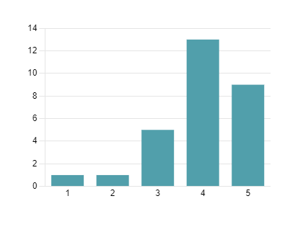
It is worth noting that the person that scored the event as 1 was unable to attend due to the weather conditions and would have appreciated more communication about the event and an option to join online.

Question 2 - The event aimed to have a range of ways to build
understanding and connections. We're keen to understand what you found most useful? (please select up to three)

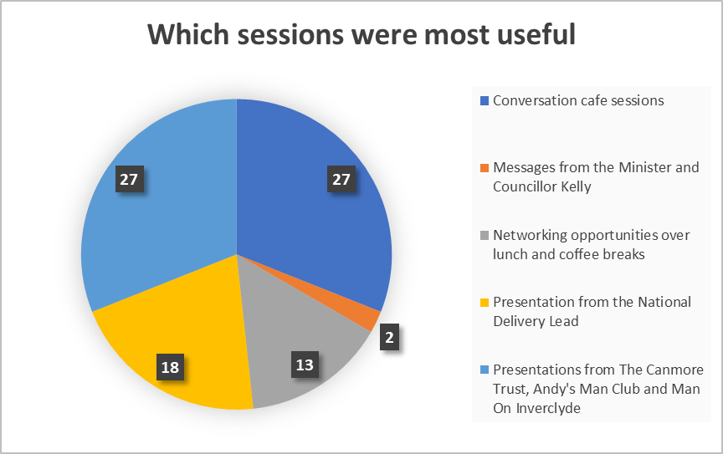

Question 3 - What do you feel worked well at the event?

Three main areas that worked well were identified:
- Conversation café sessions
- The mix of people and organisations in the room and ability to mingle and network with each other Presentations from the organisations.

The inclusion of lived experience was also mentioned as a powerful motivator.
event?
Question 4 - What could we have done to improve the event?

There were several comments that while attendees appreciated that the Minister has a busy schedule, they would have appreciated her being there for at least a short time rather than a recorded message.

Feedback on the conversation cafés included:
- Participants would have appreciated more time for discussion
- Perhaps fewer topics should have been covered
- Some topics required some more facilitation for purposes of structure, keeping on topic and drawing people in.

Other feedback included:
- A desire for increased networking opportunities which encouraged linking with other people and helped people move outwith their known groups
- That the room was too warm, and that, if there had been full attendance, it may have been cramped and
- The open nature of the room made conversation cafés more difficult.

Question 5 - How likely would you be to attend Suicide Prevention Scotland events in the future? (where 5 = very likely and 1= not at all)

The average rating for this question was 4.86, a total of 27 respondents stated they were very likely to attend future events.
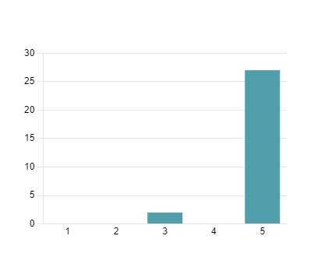
Question 6 - What topics would you like to have covered at future events?

The feedback about topics to be covered at future events included:
- Training -
  - The different training opportunities available
  - Training for trainers so organisations can build capacity
  - Ensuring ASIST is available to guidance teachers
  - Parity between third sector and statutory services for training updates and on plans to develop and sustain training, including progression on supporting all sectors not just those dedicated to mental health and suicide prevention.
- A focus on children and young people
- Understanding what the research and data is telling us about suicide both in general and at local area level, and what it is telling us about postvention support
- Partnerships, working examples and sessions to help people make connections with other organisations and find out about their work.
- Also giving a voice to grassroots/third sector organisations to share what the priorities they know need to happen are.
- More mental health education topics.

Question 7 - Is there anything else you'd like us to know about the event?

Feedback was generally positive, and people found it well organised and enjoyed the event.

There was feedback that accessibility could be improved both in terms of materials and rooms layout.

One specific point was that it might have helped with connecting if there had been lists of organisations present that were easy for attendees to access as not knowing who was in the room could mean that opportunities were missed.

Next steps
Suicide Prevention Scotland are grateful for the time and effort attendees put into the day. The discussions have provided lots of rich material which will support future developments. There are two key ways we will utilise the information from the conversation café sessions. Firstly, where appropriate, this will support development and implementation of our next delivery plan. Secondly, where we are not able to include the information in the delivery plan, we will utilise this when developing the next action plan from 2025.

It is clear from the feedback that there is an appetite for further events of this type. Suicide Prevention Scotland will include this feedback as we develop our programme of events for the coming financial year (2024/2025).

