Aberdeenshire’s Progress on The Promise at 28 March 2022

A Good Childhood
Aberdeenshire’s Aim:
Actively promote brother and sister relationships where children are placed together and /or apart.

A sibling file audit was completed by Aberdeenshire Council Children’s Services in November 2020. It noted:
- A marked disparity between the knowledge, focus, assessment, decision-making and planning regarding contact between brothers and sisters compared to the wealth of information available regarding parental contact
- The views ascertained from children, young people and their parents often did not make specific reference to brother and sister contact, thoughts/wishes around this or differentiated in terms of the contact between a child and each of their siblings and not just in regard to sibling contact in general.
The findings led to several clear recommendations being made to improve practice and a further review of children’s cases is planned to understand the level of improvement. Looked after Child Reviews and Children’s Advocacy have also been asked to actively promote good practise and challenge poor practice with this regard.

CASE STUDY:
When two sisters could no longer live at home with their mum, one was able to live locally with her father and the other went to stay with foster carers, who also lived locally. Both girls attend the same school, who were able to promote and support them to spend time together, both at playtime, and after school: playing board games together and enjoying each other’s company. During the COVID-19 lockdown, both children used the Learning Hub at school, which was promoted as an option by the school even though one of the girls didn’t strictly ‘qualify’ for a place.

Aberdeenshire’s Aim:
Public, private and third sector organisations will endorse and support workplace opportunities for care experienced young people throughout Aberdeenshire and beyond.

Our Family Firm (OFF) is a framework which allows us to identify and provide bespoke placements for young people who may benefit from the chance to spend time in a particular working environment. It is part of the wider corporate parenting approach which aims to support young people as they move into adulthood.

CASE STUDY
Susan* is a care experienced young person who lives in Aberdeenshire. This year she successfully achieved a Foundational Apprenticeship in Social Services (children and young people) SCQF level 6, National 5 English and gained full time employment as an Early Years Support Worker with Aberdeenshire Council.
Susan was referred to Our Family Firm in May 2020 and she expressed a clear interest in working with children. Several childcare placement opportunities were identified, however the onset of COVID 19 significantly disrupted Susan’s proposed plans. In view of this, other possible options were explored related to childcare and after some thought Susan decided the best option would be to return to school where she would have the opportunity to complete a Foundational Apprenticeship in Social Services (children and young people).
Following further enquiries Susan was supported by Our Family Firm to apply for the course and was enrolled at a new school. She also reconsidered her possible route into childcare and following further conversations with her foster carer, social worker and positive feedback from her Foundational Apprenticeship tutor recognised the opportunity to complete National 5 English would also help her to progress within the childcare sector.
Susan was keen to complete National 5 English but not in a classroom setting. Our Family Firm supported her to access an English Tutor through E-Sgoil, a programme for disrupted learners. Following an initial meeting with her English Tutor Susan attended virtual classes twice a week.
The amount of commitment required by Susan to complete both qualifications cannot be underestimated. A weekly task calendar was set in place and each week virtual and when possible, meetings in person took place. This helped to ensure the coursework was on track, any issues could be addressed, and deadlines met. During all of this Susan carried on despite many other upheavals in her own life and with the ongoing pandemic and resulting lockdowns.
Following the completion of both courses Susan applied for several jobs including the Early Years Support Worker. She was keen to follow any advice from Our Family Firm regarding the application and possible interview. Having gained an interview she was keen to update on how this went and then was excited to report that she had been successful

Aberdeenshire’s Aim:
To ensure our care experienced young people have the right skills and support to move when they are ready to live independently.

CASE STUDY
Paul* felt that his key worker always gave him sound advice and assistance, which resulted in him agreeing to a trial stay at the Throughcare and Aftercare (TCAC) Resource House when he was about 19 years old. He had an initial 2-night stay, and very openly admits he was “terrified”, and doubted his ability to be independent in any way.
In his own words he states that with the “backing, support and a bit of a push from his TCAC worker and TCAC Accommodation Officer, he slowly built-up confidence and coped well. This gave him confidence to have a second stay which was for 3 nights, and then 1 week and laterally 2 weeks.”
He states that by the time he had completed his stays at the Resource House he had self-satisfaction, new self- belief, confidence and pride. He cites various factors which assisted whilst utilising the resource, such as budgeting, taking responsibility for the property, problem solving and having to use different bus routes.
Paul is very clear that, without the level of support he received, he would not have tested himself to that degree. He has since progressed onto a Supported Tenancy, and states that “he felt excited and ready for the transition to independence.” He spoke of the level of support afforded to him as “perfect” in his opinion, and felt “respected” throughout.

Aberdeenshire’s Aim:
The voice of care experienced young people will be integral to service design and delivery.

The Young People’s Organising and Campaigning Group currently consists of around 12 looked after and care experienced young people who campaign and highlight issues relevant to being looked after away from home so that corporate parents can improve the services they provide to these children and young people. They have developed a “Guide to Meetings” and video and a “Guide to Coming into Care/Moving Placements” and video to be used on an ongoing basis by social workers.

YPOC’s latest campaign ‘Coming into care’ was presented during an event for Children’s Services in 2020, during lockdown. This involved members of YPOC doing a presentation, showing their DVD and taking questions from over 60 Children’s services staff.
Members of the YPOC have been working with a small group of social work staff to pull together a final version of the checklist and the guidance. Completed checklists are to be taken to the first looked after review and the review managers will monitor their use and effectiveness.

Bright Spots
Aberdeenshire were one of 3 local authorities to successfully pilot the Bright Spots Project with Celcis and Coram Voices. We successfully heard from 68% of our care experienced young people and 41% of our care leavers. Awaiting collation of themes and this will inform the next iteration of our corporate parenting plan in line with the Promise

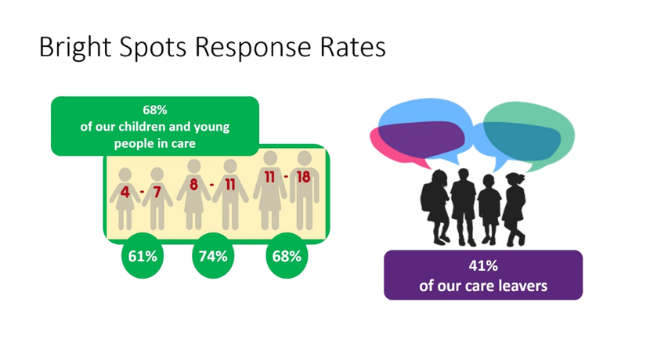

Whole Family Support

Aberdeenshire’s Aim:
Create the opportunity for intensive wrap around and sustained work with children and families before crisis but displaying early flags of vulnerability

“Supporting Local Families” based in Buchanhaven School in Peterhead will focus on how universal services can come together to provide early interventions to families in need of support by supporting families to develop increased resilience and capacity.

The aims of the project are to work collaboratively with families to co-design a system of support that is non stigmatising, holistic and builds family capacity and resilience based on strong, trusting relationships with members of the Supporting Local Families Team and in particular Family Link Workers who are supported through strong connections with the school nurse, speech and language therapy, clinical psychology, early years practitioners and local police.
At this point in the pilot, families are identified by the school team and are approached with a view to inviting them to participate. If the family consent, the initial focus is to begin to build a trusting relationship in order to begin to work with them on the areas they identify as being something they would like help to work on and change. This could be anything from financial strategies, education/further learning and/or employment opportunities, mental health, or help with child routines and Behaviour.
Some of the indicators currently being used include: domestic abuse, substance misuse, mental health, school attendance, managing a child’s behaviour, offending, housing, unemployment, financial challenges and a lack of trust in services potentially offering support.

Aberdeenshire’s Aim:
Create the opportunity for wrap around, sustained and intensive work with children and young people (12 – 26) in care, on the edge of care or edging to care or have recently moved to supported or independent accommodation, including those who have offended or are at risk of offending

The pilot has been designed to test the hypotheses about the impact of creating a ‘prototype’ multi-agency/multi-disciplinary team to trial new ways of working with families and children who are edging into care, in care or leaving care but at risk of breakdown of where they are living and negative destination. The team will support families and children between the ages of 0 – 25, who are already open to social work. The aim of the work is to support children and young people to remain within their families and/or within their communities, avoid the use of expensive out of authority care and help them achieve improved and sustained lifelong outcomes.

Having made strong local connections with our CAMHS service who have seconded a clinical psychologist to this work, we have also secured initially 6 hours support per month for our three children’s homes in Aberdeenshire from a CAMHS practitioner to support both staff resilience and wellbeing in care for care experienced young people but also offering consultation and guidance to support staff to respond therapeutically with an increased knowledge and understanding of the impact and response required by young people who have experienced developmental trauma.

Supporting the Workforce

Children’s Services social Work through bi-monthly whole service virtual Time to Talk sessions have been piloting how we record and use language. This has resulted in innovate practice including:
- The piloting of Pathway Review Minutes being written as a letter to the young person by the review chair. Really positive feedback from young people and other partners about the use of language and how accessible the minute is.
- The piloting of Observations/case recording of one to one meetings between a social worker and a young person being recorded in the child’s file as a letter to the young person. Brings the recording to life and captures the nuances of the child’s relationship with the worker and creates memories
- The implementation of the child and young person’s assessment written in child friendly language with a photograph of the child or a photo of their choice about something they like at the front of the report. Innovative use of improved language and banning of words including ‘contact’ ‘sibling’ contact, LAC and all reports written in first person. No more ‘the writer’
Planning

Aberdeenshire have set up a multi-agency Promise Implementation Board with partners and members with lived experience to over see the implementation of the Promise and sponsor transformational change that meets the Promise recommendations with a view to testing change and implementing evidence based good practice. The Board is currently mapping out multi agency transformational change and improvement activity that aligns with the Promise with a view to identifying gaps and supporting innovation to meet need around the gaps identified. The voice of lived experience is central to this work.

Leigh Jolly
Head of Children’s Services/CSWO

