Moray Council Annual Report on The Promise
A Promise and GIRFEC Lead Officer has been appointed by Moray Council to co-ordinate the delivery of the Promise in Moray. In addition, funding has been secured through the Corra Foundation - The Promise Partnership, which has allowed for two further posts to be recruited - Promise Project Lead and Promise Engagement Officer.
The initial focus has been on undertaking a comprehensive self-evaluation, which has pulled partners together to understand how well we are keeping the promise in Moray. This has involved investing significant time in building trusting relationships with children, young people, families and the workforce who currently support them. This has provided a baseline of current situation and assisted in the prioritisation of actions required to deliver the 2021-24 Change Plan.
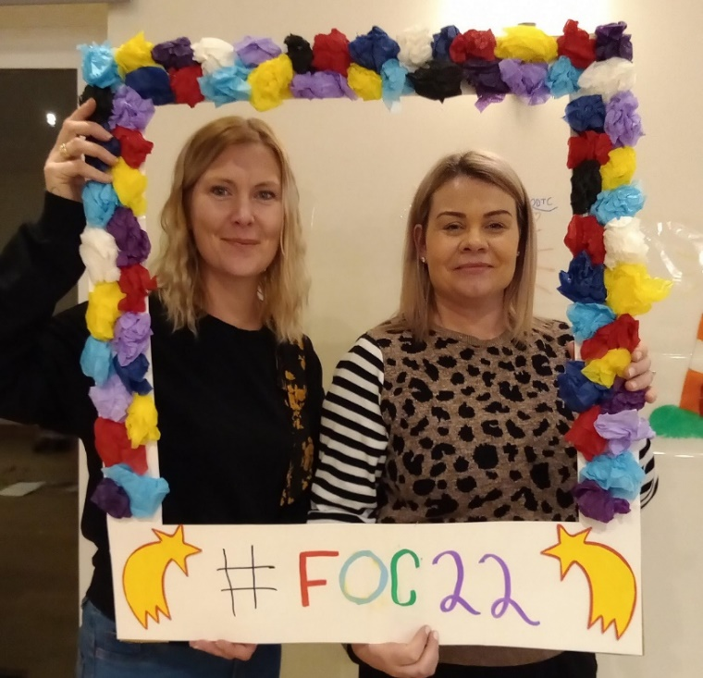
(Pamela Davidson, Promise Project Lead and Kelly Erker, Promise Engagement Officer Festival of Care Residential)
As requested, the template below highlights one key area for development. Under the five sections within The Promise Plan 21-24.

A Good Childhood | Support (Health)  The process of Health Assessments and Strengths and Difficulties Questionnaire for Looked After Children has been explored. 90% of these assessments were taking place within 4 weeks.  Through connecting with young people who have gone through this process in the last 12 months we were able to capture their voice on the Health Assessment process and whether and how the information is used in their meetings. We are currently working with our Lead Looked After Children Nurse to make changes where identified by young people.  ‘Why does the school nurse have to be there after she has said her bit?’  Quote from a young person in residential services. (This is the young person’s account of her LAC meetings).  Collation of the data and the voice of young people and professionals is informing where changes can and will be made to the current processes.
Whole Family Support | An intensive whole family support improvement project is being developed and implemented on a partnership basis with support from the Scottish Government Regional Improvement Advisor.  This project adopts a blended model of service design and quality improvement in order to explore how our ways of working can cross organisational boundaries to better meet the needs of families facing adversity.  In Moray, the highest reason recorded for children being on the Child Protection register is parental substance misuse, with that in mind, the initial focus is on working with families experiencing these challenges. £100k has been secured from Corra Foundation through a joint funding bid (NHS and Moray Council) This funding provides the additional capacity required to progress this work at pace.
Supporting The Workforce | Within Moray’s social work department, the staff have been attending training and co-designing a new model of social work in Moray that better keeps the the promise. This is a transformational change to the way social workers work alongside families, from initial referral through to closure and works to ensure practitioners ‘wrap around’ families, as opposed to families being passed through different teams. The council has agreed significant investment to this new model and allows for the Moray Children’s Planning Partnership to support children at home and prevent episodes of care. Alongside other partners, social work are using the Outcome Star to evidence positive outcomes.
Planning | We have secured a number of areas of funding that help us keep the promise. We have a new mental health Tier 2 provision to support those young people and their families who were otherwise falling through the net of CAMHS support.  An investment has been made by Moray Council for 2 further commissioned services, one being Functional Family Therapy to prevent children being removed from their families at crisis point and the other is an early intervention restorative support for families, to enable children, young people and those they live with to leave the ‘system’ at the earliest opportunity.
Building capacity | 22 young people have contributed to the Better Meetings Project supported by; Who Cares? Children Hearings Scotland and Social Work (Highland and Moray). Improvement work to deliver the changes requested by young people is in development.  This includes physical redesign of rooms where Children’s Panels are held, as well as changes to how meetings are run. Due to the pandemic Children’s Hearings have at times been conducted with the young person taking part via online, this has allowed greater participation and the continuation of this new way of working will be facilitated. A checklist for the Chairs and members of Children’s Panels, as well as social workers to ensure the views of children and young people are evidenced in reports and in meetings is being tested.

