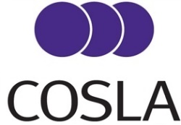

LD/22/0132

There will be a COSLA Leaders’ meeting on Friday 30 September 2022 at 11am at Verity House and via MS Teams.

Sally Loudon
Chief Executive

AGENDA
Public Session

- Introduction
- Draft Minute of Leaders 26th August, and continued 2nd September. Special Leaders 27th August. (LD/22/0133 and LD/22/0134)
- Presentation from Accounts Commission Chair (Bill Moyes)- presentation and questions
- Local Authority Mutual Investment Trust (LAMIT) Board (LD/22/0135)

Private session

- Local Government Finance Update (LD/22/0136)
- Pay Claim 22/23 Update (LD/22/0137) – to be issued Wednesday 28th September
- COSLA Plan 2022-2027 Update (LD/22/0138)
- National Care Service (LD/22/0139)
- National Care Service - Children’s Services Reform (LD/22/0140)
- Update on Joint Statement of Intent (LD/22/0141)
- Winter Planning – Health and Social Care (LD/22/0142) – to be issued Wednesday 28th September
- Programme for Government 2022-2023 (LD/22/0143)
- Disabled Children and Young People (Transitions to Adulthood) (Scotland) Bill (LD/22/0144)
- Distribution (LD/22/0145)

