Appendix 1

Understanding the demographic challenge

Scotland as a whole is facing a significant demographic challenge. Our population is ageing, which means that the proportion of elderly people is increasing as a proportion of the total population. The problem we face as a nation is that as the elderly population increases as a proportion of the total there will be increased pressures on social services but fewer people of working age to provide these services and fewer taxpayers to fund them. However, the demographic position of local authorities across Scotland is not homogenous. Some have a population that is projected to increase overall, and some areas are even likely to experience the growth of their working age population as a proportion of the whole. The two areas of concern are whether:
1. An areas’ total population is increasing or decreasing; and
2. An areas’ working population is increasing or decreasing as a proportion of the total population.

Areas in which both of these are increasing are in the strongest demographic position, whilst areas where both are decreasing are in the weakest demographic position and are likely to experience a range of problems and challenges. Please note that we have not looked at whether the working age population is increasing or decreasing overall, but have instead considered how this group is changing as a proportion of the total population. This gives a better sense of how the dependency ratio is changing within an area. The following chart and table look at local authority population characteristics in relation to both these demographic issues give a brief prognosis of the challenges likely to be faced in each case. The table uses NRS’s projections for how each local authority’s population might change over the period 2012-2022 if current trends continue. We have used this period since population projections are more accurate over a reasonably short period. 2014-based projections for Scottish council areas will be published later this year.

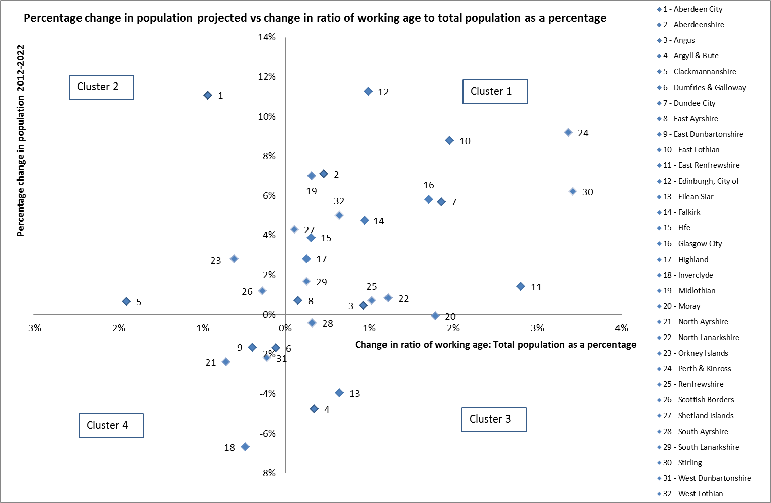

 | Population Projected to Increase 2012-2022 | Population Projected to decrease 2012-2022
Ratio of working age : Total population projected to increase 2012-2022 | Cluster 1  Characteristics:  - The total population of the area is increasing  The working age population is increasing as a proportion of the total population  Prognosis:  This is probably the best situation for a local authority to be in. The increasing total population may lead to increasing demand on services, but this demand is supported by a significant working age population (as long as worklessness can be kept low).  Local authorities:  Aberdeenshire  Angus  Dundee City  East Ayrshire  East Lothian  East Renfrewshire  Edinburgh, City of  Falkirk  Fife  Glasgow City  Highland  Midlothian  North Lanarkshire  Perth & Kinross  Renfrewshire  Shetland Islands  South Ayrshire  South Lanarkshire  Stirling  West Lothian | Cluster 3  Characteristics  - The total population of the area is decreasing  - The working age population is increasing as a proportion of the total population  Prognosis:  This is a reasonably good situation for a local authority to be in. Demands on social care services are likely to be manageable because the working age population is increasing as a proportion of the total population ( although worklessness may still be an issue). The biggest risk for these local authorities could be depopulation.  Local authorities:  Argyll & Bute  Eilean Siar  South Ayrshire  Moray
Ratio of working age : Total population projected to decrease 2012-2022 | Cluster 2  Characteristics  - The total population of the area is increasing  The working age population is decreasing as a proportion of the total population  Prognosis:  This is a potentially difficult situation for a local authority to be in. The total population is increasing, but the working age population as a proportion of the whole is shrinking. This will lead to increased demand on social care service and a smaller workforce to provide these and other services.  Local authorities:  Clackmannanshire  Scottish Borders  Orkney Islands  Aberdeen City | Cluster 4  Characteristics:  - The total population of the area is decreasing  - The working age population is decreasing as a proportion of the total population  Prognosis:  This is possibly the worst situation for a local authority because of the likelihood of depopulation leading to decreased viability for some services, coupled with a growing non-working aged population and linked demand for social care services with fewer working aged people to work in this sector.  Local authorities:  Inverclyde  North Ayrshire  East Dunbartonshire  West Dunbartonshire  Dumfries & Galloway

