FIFE COUNCIL – DELIVERING ON THE PROMISE THROUGH A COMMUNITY SOCIAL WORK APPROACH
Fife Council Education and Children’s Services is developing a community social work model which works alongside children, their families and the communities they live within. This approach aims to not only address wider issues of risk and vulnerability through the lens of poverty, discrimination, social exclusion and structural inequality, but to also identify the strengths that people hold within themselves and the community, to find solutions to shared problems.
Our aim is to work in a preventative way with people and the wider community, rather than reacting to individual crisis or intervening when it is sometimes too late to hold families or communities together. The development of Community Hubs has enabled the community to have their voices heard about what is important to them and to work alongside Community Social Workers to address the issues they wish to find solutions to, which will improve outcomes for themselves, their families and their community.
The “Community of Ideas” board was developed by people attending 2 Community Hubs, supported by the Community Social Work Team in Kirkcaldy. Programmes are now in place in response to what local people have asked for and feedback indicates there have not only been positive outcomes for individuals but also for the community as a whole.

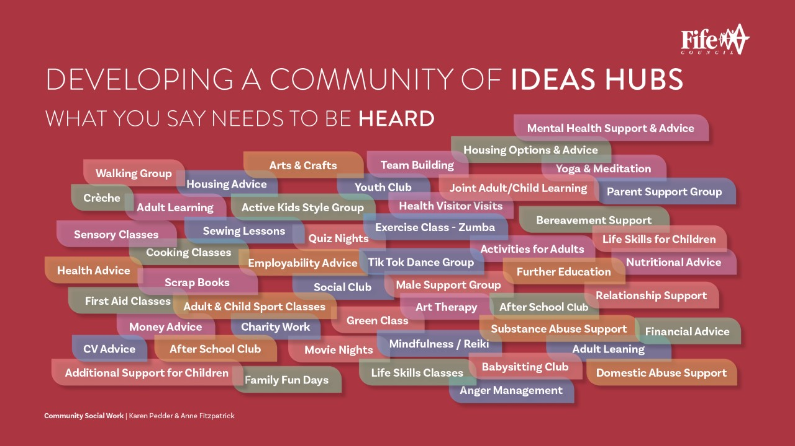

Feedback from The Hub
“Engagement with the pupil council has increased – parents attending The Hub appear more confident about their capacity to participate in decision making forums”
“1:1 sessions have supported a father who was struggling to care for his child – without this he may have relinquished care of the child – The Hub has kept a family together and increased father’s parenting capacity”
“Parents are “raving” about The Hubs and what they have taken from it”

